The Breeze Volume 4 April 2011 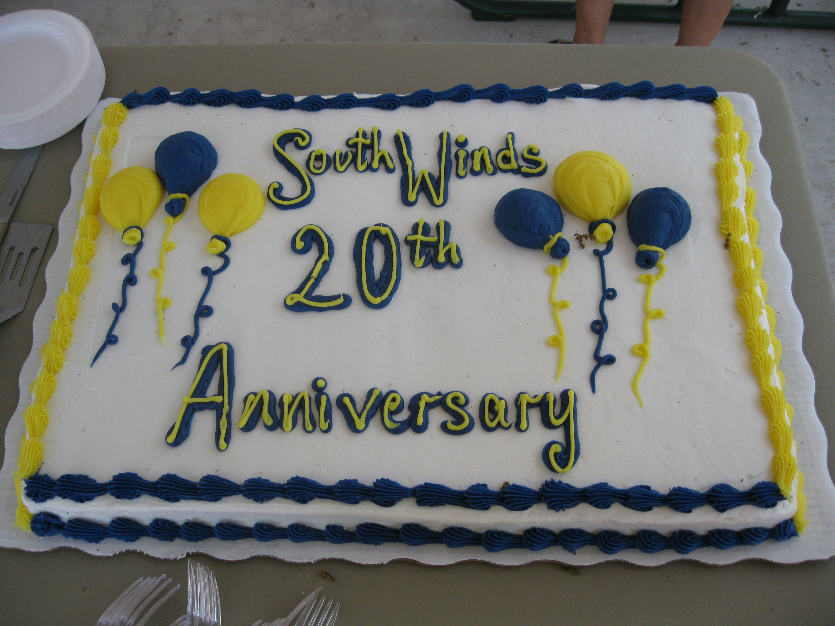
THE PREZ SAYS…

It may be a cliché but time does fly when you’re having fun. It seems as if we just got together to celebrate Halloween, Thanksgiving and Christmas and we are talking about “going north”. South Winds was once more an incredible place to spend winter. Certainly the weather was as close to perfect as it could be. And, because each of you was here, people rose to the top as a reason to come again. I want to thank each of you for all you do to make living at South Winds such a pleasure.
I would be remiss if I did not recognize Elinor Wells for her leadership during a year that was alive with activity and accomplishment. To the entire Board: good job!
As we prepare to leave, don’t forget the basics of being good neighbors. Please make sure that someone will be responsible for the upkeep of your yard in your absence. Don’t forget that many of your friends live here all year and want the neighborhood to look as good all summer as in the winter. Board member Paul Rodriguez will be checking and fines will be assessed for offenders. Summer storms can be fierce. Please secure your home so that it does not become a danger to a neighbor. Absolutely nothing should be left on your drive, patio or in your yard. In a hurricane EVERYTHING is a projectile.
Know that, even though your Board of Directors is out of the park, the park is not out of its thoughts. In the May Breeze there will be contact information– please use it. Joani and Bob are willing to be available 24/7 so, if you need them – contact them. They are within minutes of the park. If you need maintenance please contact the office and Joani will complete a work order. If you have a suggestion/comment or complaint -- put it in writing, take to the office and it will be dealt with immediately. If it isn’t in writing and isn’t signed – IT DOESN’T EXIST.
Have safe travel and come back ready to enjoy another season.

THANKS FOR THE GIFT OF SOUTH WINDS
OHIO SHOULD BE PROUD
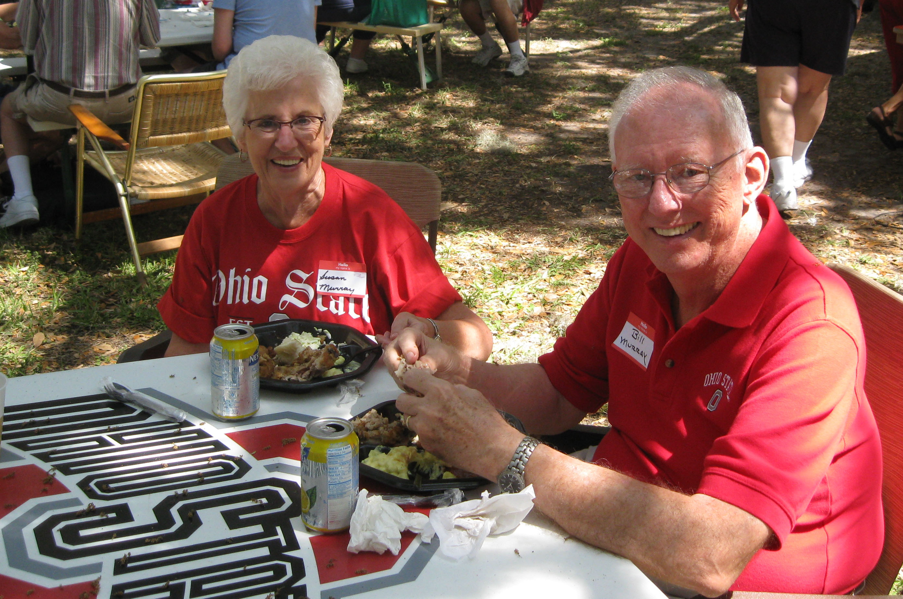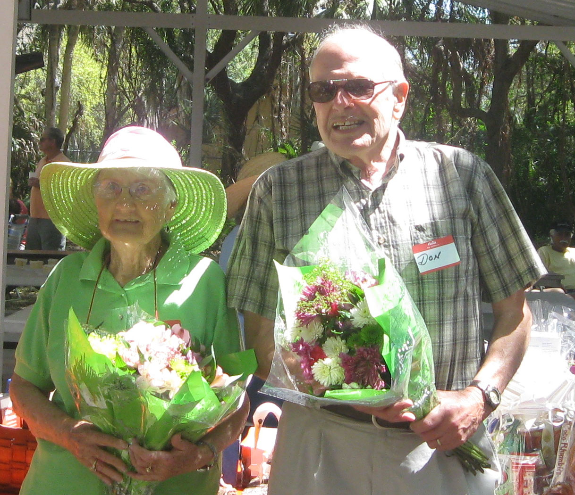

ANNUAL MEETING

On March 5th the annual homeowner’s meeting was held in the Rec Hall. Elinor Wells opened the meeting at 8:30. As there were only three candidates for the three positions on the Board. there was no election. Dave King, Jerome Miller, and Dick Mosher were installed for the next three years. After the regular meeting, another open meeting was held to elect officers and Dick Mosher was elected President, George Manton - Vice President, Barbara Smith - Secretary, and Jerome Miller - Treasurer.

Jerome Miller, our treasurer, with the help of George Manton, gave a presentation of the financial status of the Park and presented the new budget, which included a $15 increase in maintenance fees. He outlined a lot of the updates that were done this past year, as well as office and maintenance costs. Our accountant was present and spoke to the great financial standing of the Park. A recommendation was made by the Board to accept the budget and to vote no on waiving the funding for the reserves. The budget passed and Reserves will not be waived.
Editor’s comment: We were informed a couple of years ago that the meeting for electing officers should be open to everyone instead of the way it has always been handled with a closed meeting in the card room. The Board agreed. The agenda were published as per By Laws. NO ONE but Board attended.
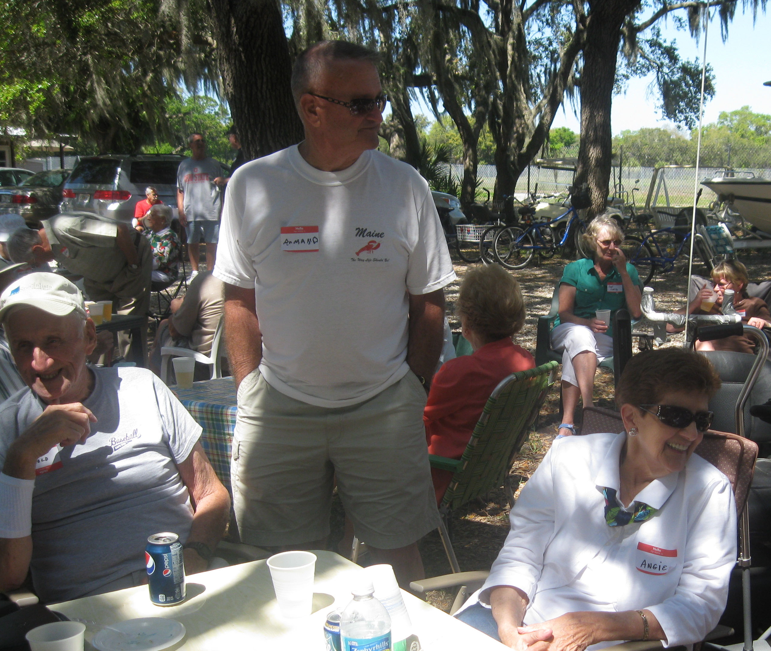 PICNIC

Our annual Park Picnic was held in our neat little park at the rear of our property. It was hosted by the residents of Ohio this year and they did a great job. They served Kentucky Fried Chicken, beer and soft drinks, and dessert was cake recognizing the 20th anniversary of the buying of the Park. Gifts were presented to the three original Board members who are still in the Park, Harold Davies, Francile Huser, and Don Langlois. A picture of all of the original purchasers was also taken.
Those of us who purchased later want to give a big Thank You to those of you who had the foresight to establish this piece of Paradise for us all to share.
A raffle of money and gifts ended the formal part of the picnic. Some stayed and enjoyed the atmosphere and others went on their way.

GLAD TO BE HERE!!!

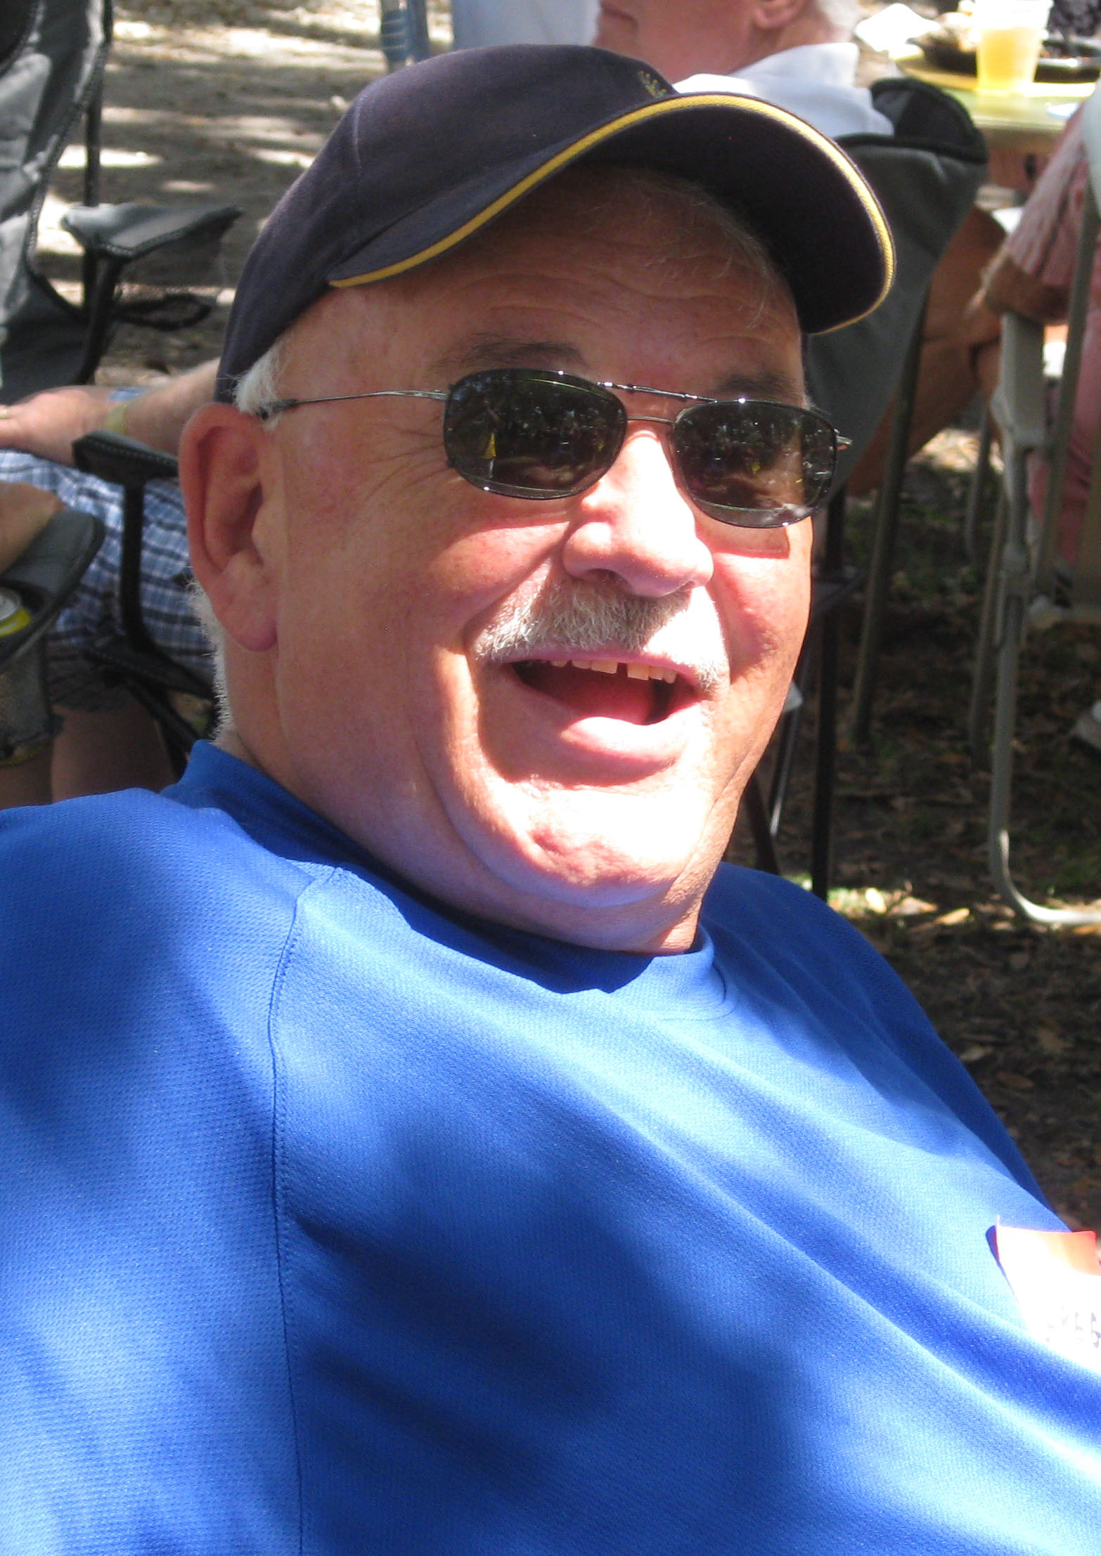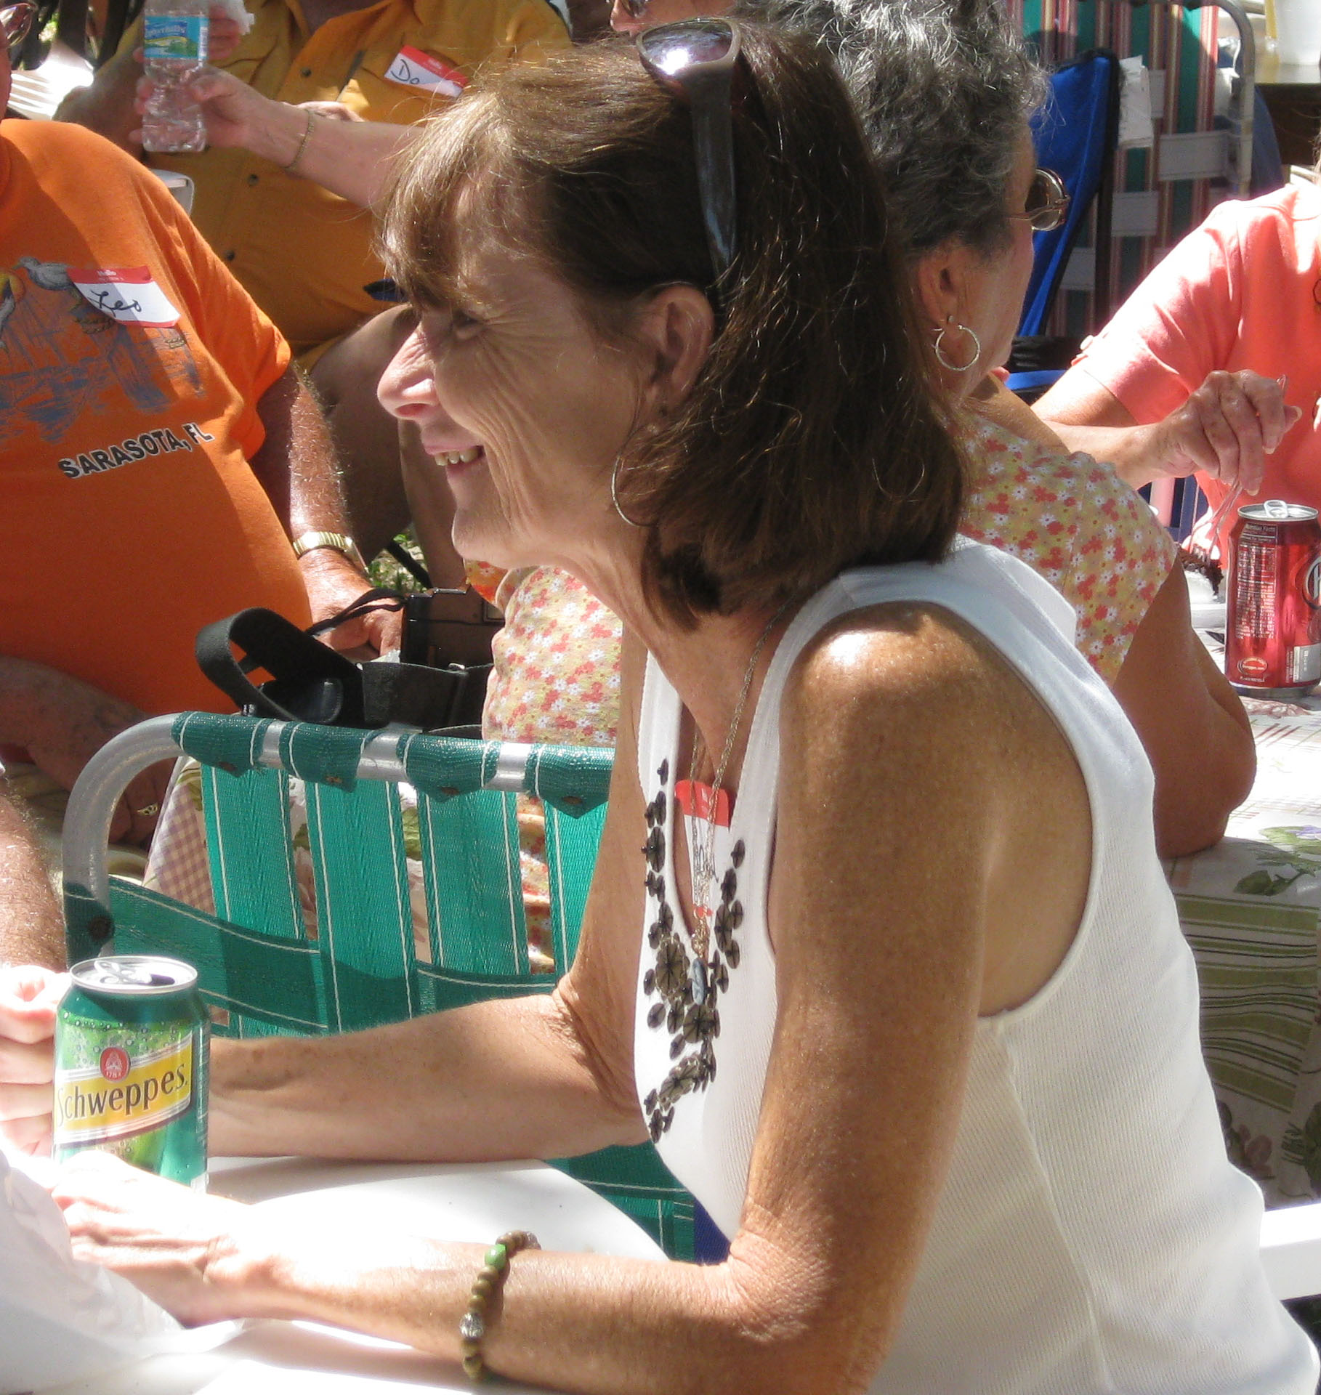

NEW RENTAL POLICY 

With the 2011 season, there will be a new rental policy for all of you who are contemplating renting your unit. Beverly Duddy, our rental agent for the past few years, has been relieved of that position. The Board has been informed that the procedure we have been following is not legal and the Board has decided that it doesn’t want to be involved in illegal procedures. A letter is being sent to each homeowner outlining the procedures that need to be followed. Please, if you are planning to rent this year, contact the office for the proper forms. The Board realizes that this may cause some problems and will try to help you as much as we can but people who do not follow the rules could be fined

SUMMER WEEDING

Each year, as the Snow Birds head north for the season, the Board states that our Maintenance Department is not responsible for maintaining your properties. Each year we have quite a few violations with which they have to deal. Keeping your property looking nice for those who are full time residents should be a matter of pride. How would you like to live next door to an unkempt flower bed and planters overflowing with weeds? Maintenance will make sure your lawn is mowed, but they do not have the time or the manpower to take care of the planters and personal flower beds. It is your responsibility to see that someone will take care of it while you are gone. They will be inspected monthly and if found unkempt, a fine will be issued. Respect those neighbors who live here year round - hire someone to take care of your property while you are gone.

AUTOMATIC DEBIT

In the past year, a policy has been adopted by the Board in which you may participate and have your monthly maintenance fee automatically debited from your checking account. This is a timesaver for both you and the office and also frees you from sending a check each month to pay this bill. If you are already involved, thank you, and if you’d like to sign up, contact the office for the proper paperwork.

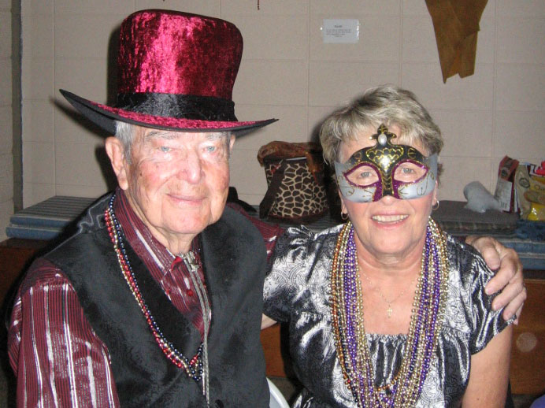
MARDI GRAS
This was held in February but too late for the March Breeze

What a great evening!! The Hall was Mardi Gras decorated (it is amazing what 2 or 3 years of preparation can turn up) and the dancers came in their Mardi Gras masks or costumes. Many people were dressed for the occasion and the rest of us just enjoyed watching them. It is so great to see the participation of so many when an event is scheduled and to see them having such a great time. Thanks again to Pat Warren and her committee for giving us another memorable evening of fun.

St. PAT’S 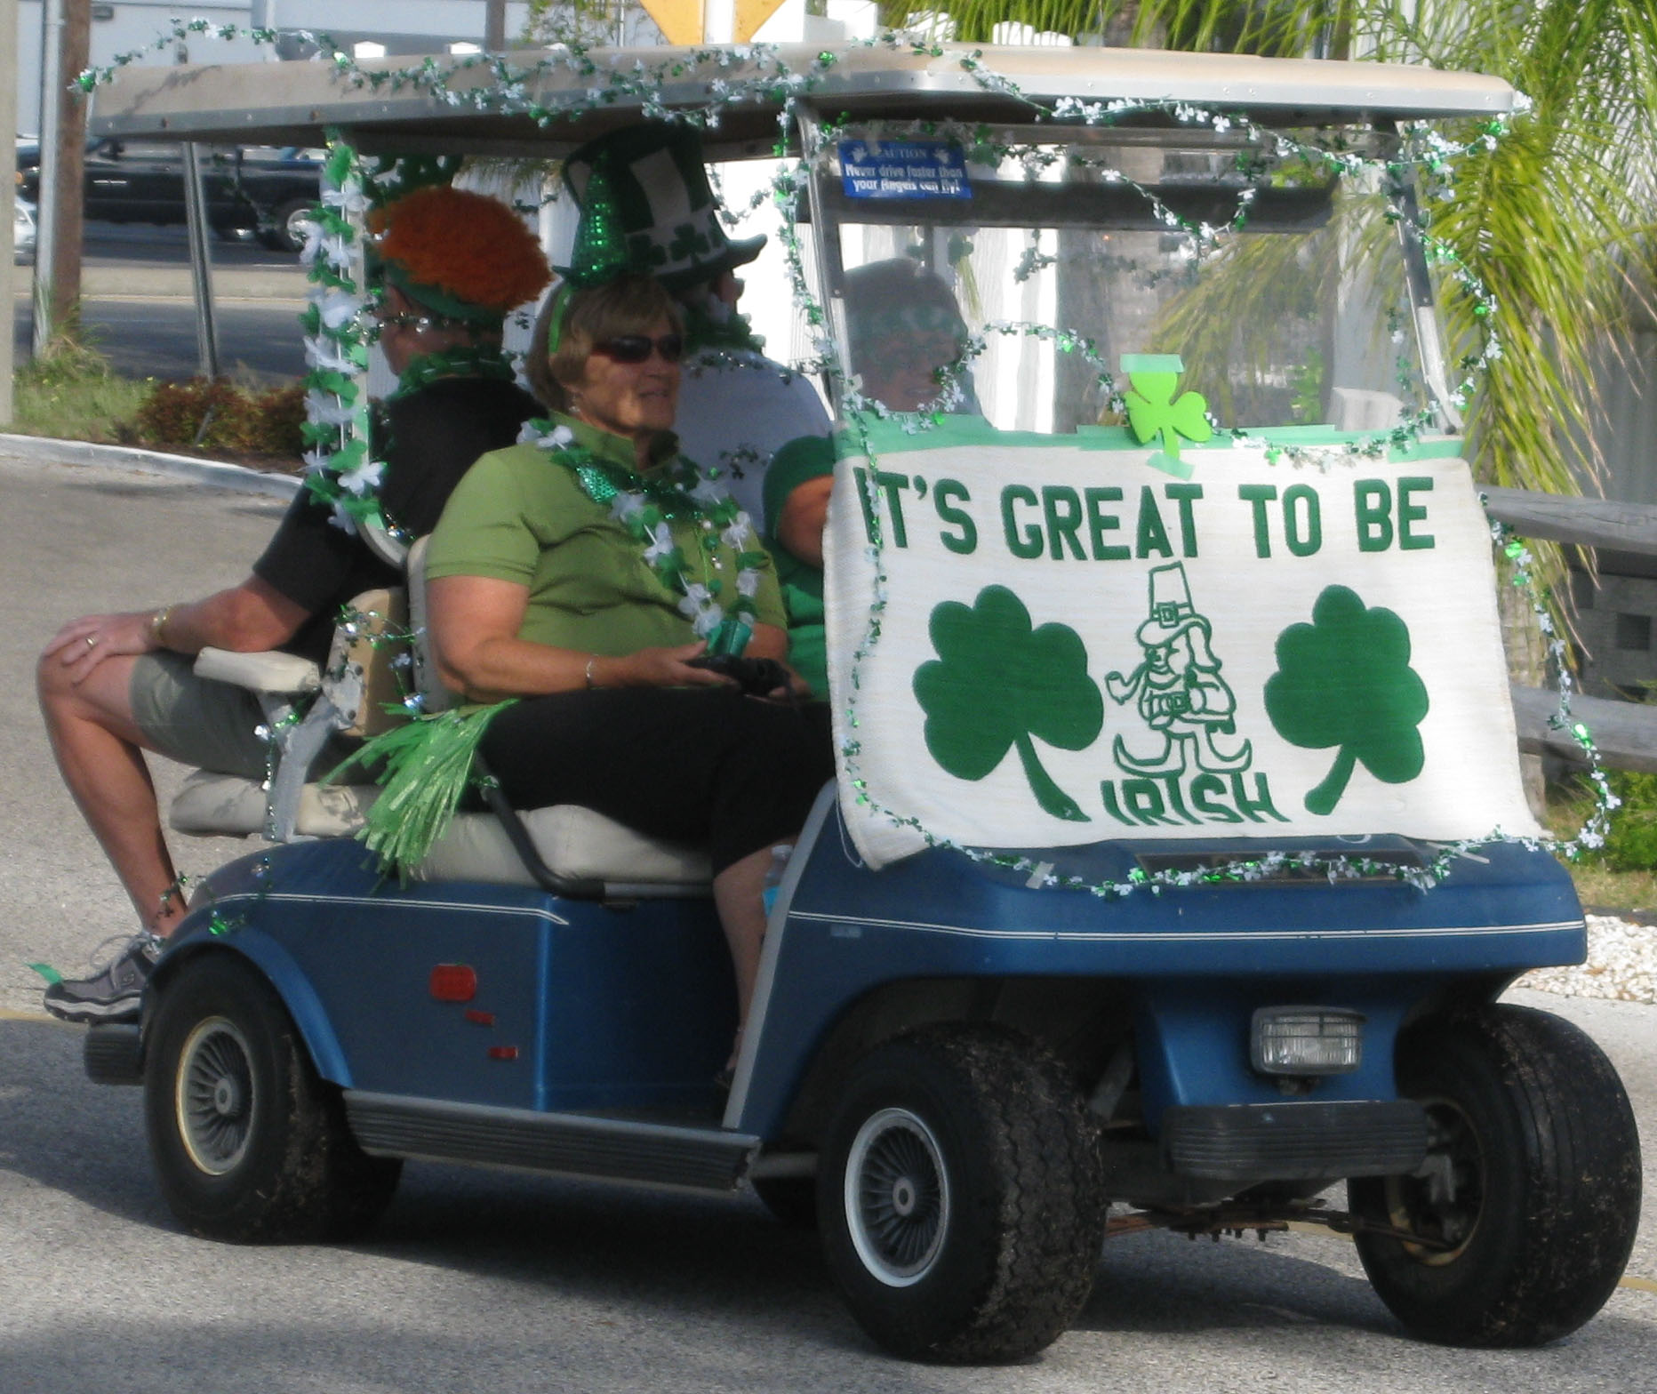

Irish eyes were smiling, the leprechauns and lassies danced the night away. The St. Patrick’s dance was chaired by Celeste Mosher and Johnna Dail. Everyone came in their Irish green and ready to party. Again, a great party with lots of dancing.
A 50/50 drawing was held with the first drawing going to Don Consalvo and then a second drawing was held for a catered dinner for the winner and 5 guests. This was won by Evelyn Coleman. I must tell you that it was a super prize as Walt and I had the honor of being invited to be Evelyn’s guests for the evening. We were wined and dined by Celeste and Dick and Woody and Johnna known as Casual Elegance Catering. The setting was the card room and you can’t imagine how elegant it looked!!! Then there was the food - champagne, appetizers, main course and dessert. We all felt like we were Queen or King for a day.
BYE BYE BIRDIE 

As many of us prepare to leave our sunny Florida residences and head north for the summer, it is time to bid farewell to our many friends and neighbors at Southwinds. This dance allows us to have a going away party for those who are (Snow Birds). The music was great and the fellowship even more so. Beer wine, soft drinks, and coffee were provided by the committee, chaired by Nancy Plumb. The tables were laden with the many goodies prepared by all who attended. A 50/50 draw was split and won by Dolly Burdette and Dave King, with the other half going to the Rec Club.

DINING OUT

ILL/WISC/ IOWA
April 8, 2011 - 11:30 am
Shuck’s Restaurant
7253 South Tamiami Trail
Signup sheet on the Bulletin Board
Info: The Kidd & Claire 924-1145

INDIANA BREAKFAST
April 12, 2011 - 9:00 am
Denny’s
8214 S. Tamiami
Signup sheet on the Bulletin Board
Info: Butler - 926-3495

OHIO DINNER
April 12, 2011 - 4:30 PM
Dutch Heritage
Info: Herb & Mimi Manton - 921-6844

PA-WV-MD LUNCHEON
April 13, 2011 - 11:30am
Marina Jack’s
2 Marina Pl
This will be the last hurrah for the season. Mark your calendars and y’al come.
Signup sheet on the Bulletin Board
Info: Windy Coulter - 927-9816



NORTHEAST LUNCHEON
April 21, 2011 - 11:30 am
The Open Pub Restaurant
Target Plaza, 8579 S Tamiami Trail
Signup sheet on Bulletin Board
Host: Celeste & Dick Mosher 942-993-9535
EVERYONE WELCOME

MICHIGAN LUNCHEON
April 12, 2011 - 11:30 am
Gecko’s Grill
4870 S. Tamiami Trail
Last one of the season, so plan to attend!!!!
Info: Shirley 922-9547

PERSONAL NOTES 

I wish to convey my gratitude and thanks for the prayers, flowers, rose bush, sympathy cards and hugs, due to the loss of my two sisters .Your caring and concern got me through a very difficult time.
Thank you to my Southwinds family for being so special.
Gratefully yours,
Pauline Villeneuve

Thank you for the beautiful flowers given to me at the Picnic. It was nice to be honored for being on the Board when we purchased the Park on 2-28-1991.
Francile

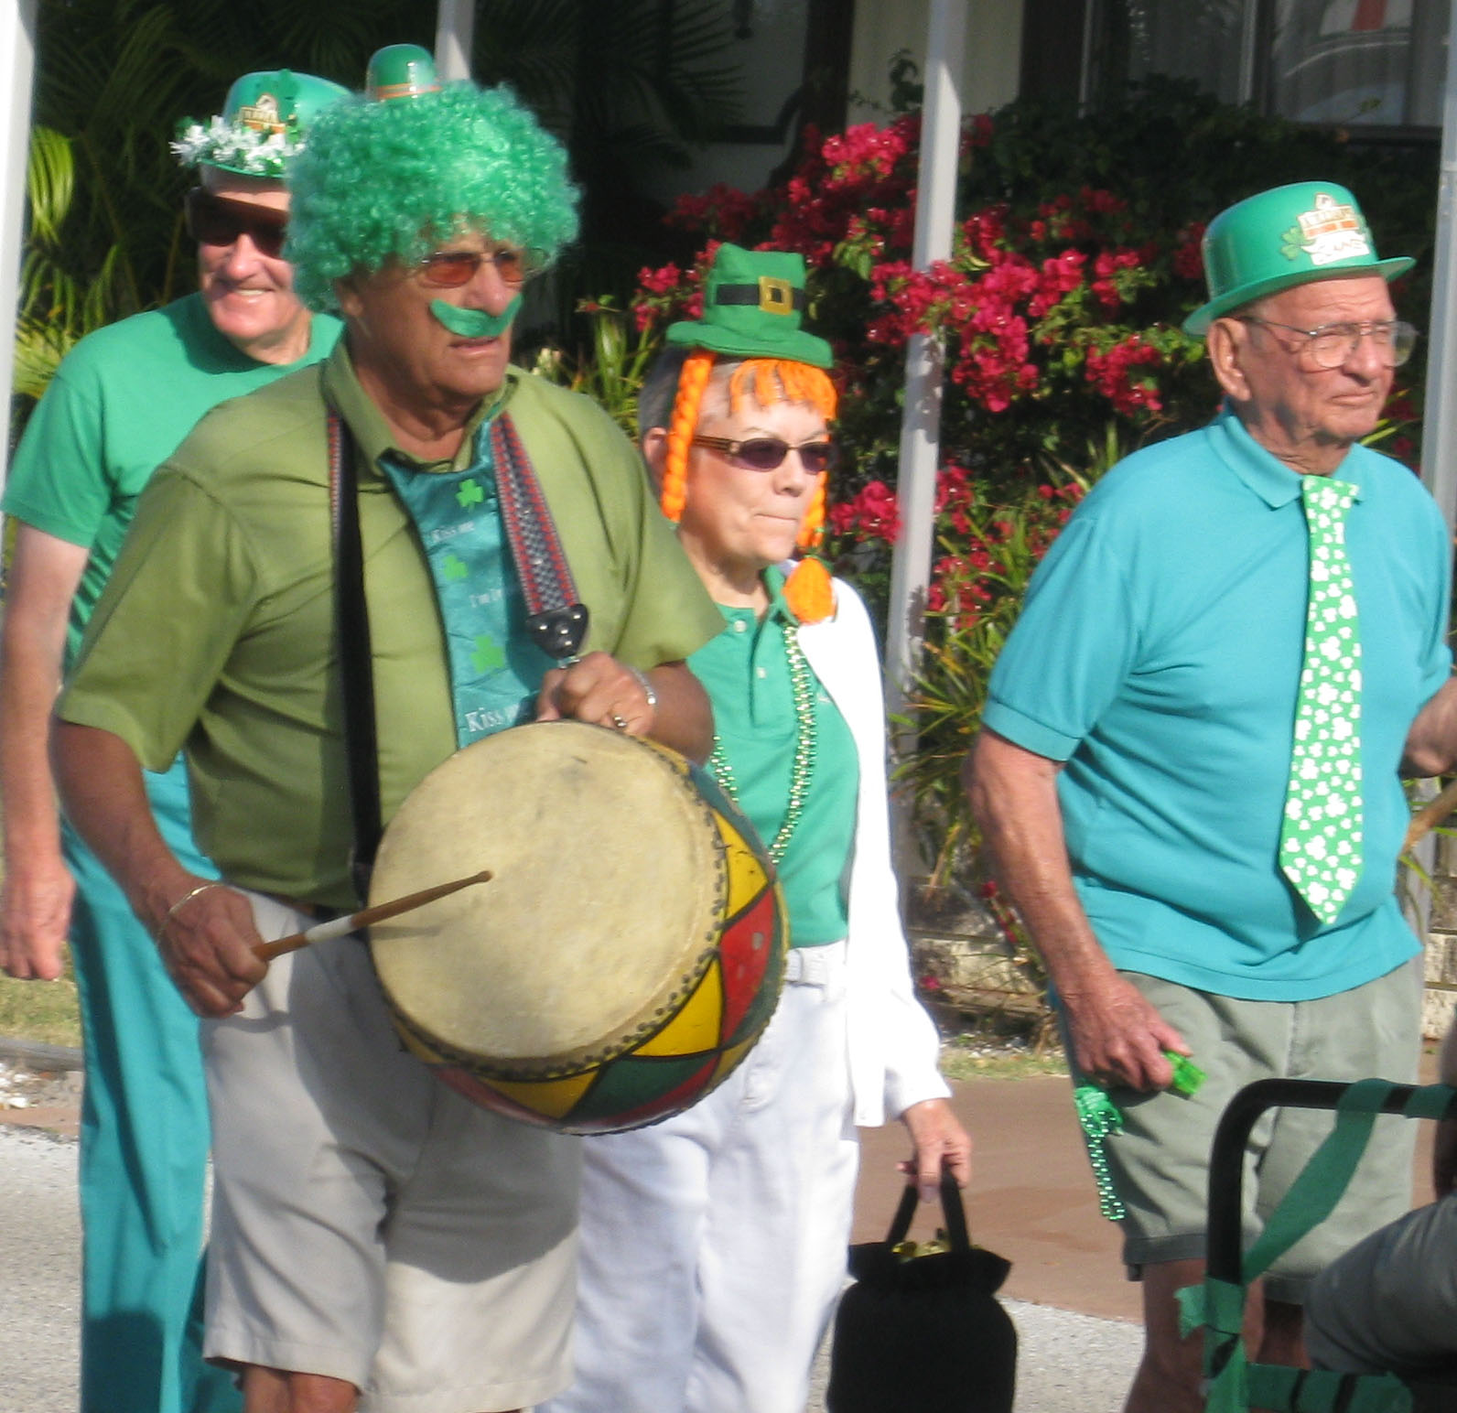PARADE

As usual, great fun was had on St. Patrick’s Day with our big parade. On Thursday, March 17th 25-30 residents showed up in their finest Irish outfits, paraded through the Park and up front to spread the cheer to by-passers. Then, back to the Rec Club for some great prizes in several different categories. Cookies and punch and true Irish soda bread were served to about 80 people
Afterward, many of the participants and other residents made their annual trip to Hooter’s for some lunch and green beer.

A GREAT TIME WAS HAD BY ALL

A tie to remember
HOBBY CLUB

Hobby Club had a very active and fun winter. Thanks to my secretaries, Annette Boettger and Jane Magnant, and my treasurer, Judy Damschroder, and to all of you for the interesting workshops.
Looking forward to next season!! Remember, bring your ideas!!!!
In the meantime, have a great summer and safe journey home.
Au revoir (until we meet again).
Pauline Villeneuve

CLOUD NINE 

Cloud Nine sponsored a trolley ride through downtown Sarasota with a narrator explaining the various points of interest. Due to the heavy response, two trips were held, one on the 14th and one on the 21st. It was an interesting and informative afternoon. They are in the planning stages for next year and have some great things planned. First meeting of the new season will be the salad luncheon in November. Any and all are invited to join.

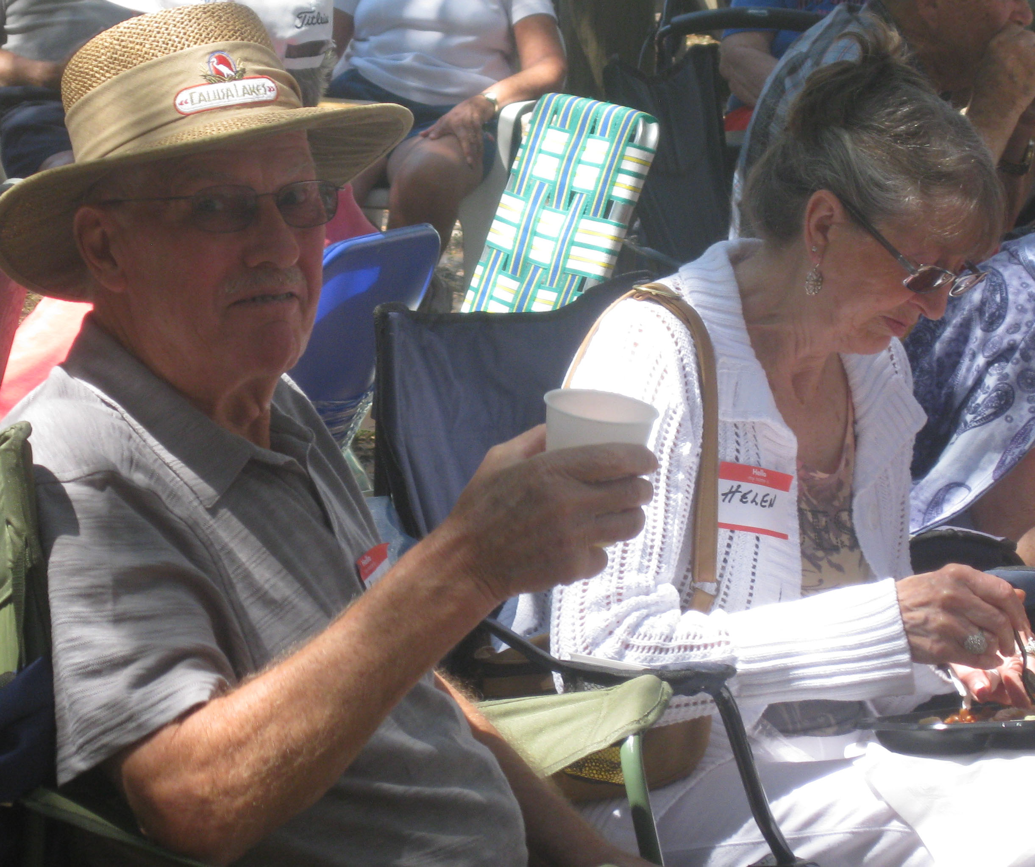
 SIP AND SING

Our park really has some unique and wonderful entertainment. The chorus, under the direction of Larry Teevens gave two performances in the Annex. Tickets were free but a free will offering was asked to cover the cost of the wine and cheese that was prepared by other volunteers. The chorus impressed us all with the variety and the quality of their music. Again, I say, we have some very talented people in our park and we need to thank each and every one of them for sharing that talent with the rest of us. I understand that the chorus is disbanding for next year, which is a shame, but understandable, when you think of all the hours of preparation that went into this performance.

ANNUAL TURKEY SHOOT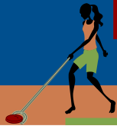

One of the fun things that happen on the shuffle courts is the annual Turkey Shoot. This is just a fun afternoon with competitors trying to outdo the other shufflers by keeping all the discs on the lines, shooting around a couple of bowling pins, trying to make 5 kitchen shots (they always go there when you don’t want them to), putting the disc through the mouth of a pig, etc. We had 47 competitors this year and ended up with a tie for Booby Prize which then had to be played off. Thank you, Evelyn Coleman and Dave Moore for being such good sports. Scores were a little low this year but winner Jerome Miller had 130 points, Keith Damschroder, 2nd - 110 points and Bill Miller 3rd - 100 points. At the completion of their round, each player was treated to a Popsicle or fudgesicle. Thanks to all who helped. Hope to see you all next year. Let‘s give these guys some competition!!!



APRIL BIRTHDAYS - 90 AND OVER
MELVIN DEMING APRIL 14, 1921
FORMER RESIDENT - SALLY SHORT APRIL 2, 1911
(SHIRLEY LANGLOIS’ MOTHER)


ANNIVERSARIES - 50 AND OVER

HERB & MIMI MANTON
APRIL 2 - 56 YEARS
ARMAND & WILMA COSENZA APRIL 3 - 57 YEARS
MIKE & NORMA JOYCE
APRIL 4 58 YEARS
MURRAY & MARY JANE SMITH APRIL 5 - 59 YEARS
DUNCAN & VERNA SANDERSON APRIL 11 -58 YEARS
BUELL & MAMIE SMITH
APRIL 12 - 53 YEARS
DONALD & JANET WALDRON APRIL 12 - 58 YEARS
HOWARD & MARY JOHNSTON APRIL 28 - 55 YEARS

TROPHY COMES BACK!!!! 

SHUFFLE CLUB NEWS
The 48 people who attended our second Annual Pizza Party on Friday, March 25, had a real treat when John Carter presented the Sara-Bay League trophy to the group. The team had learned earlier in the week that they had won first place in the league by a total of 5 games and thus had brought the trophy back to Southwinds after an absence of 7 years. Club awards at the party, Wendell Lawrence and Mike Cox were honored for their ongoing commitment to maintain the courts in excellent shape. Melita Whitney and Judy Damschroder were also honored for their considerable contributions to the Team’s participation in the league.

Many Club members will be heading back North over the next several weeks. Those still here are invited to participate in a fun Draw Doubles Tournament on Thursday, April 7, and Friday, April 8. Members will draw for partners in this tourney, producing interesting pairings and unpredictable results. Register to participate by signing the sheet on the shuffleboard bulletin board by 3:00 PM on Tuesday, April 5


PAT HARWELL & MARILYN TRANBARGER WERE HOSPITALIZED BUT ARE BOTH HOME NOW

Our sympathy

CONDOLENCES TO THE FAMILIES OF BERNIE ZIOLKWSKI and TEX GRAHAM

BOARD MEETING 4/6 ANNEX



GARDEN CLUB 

Members of the "replanted" Garden Club have been enjoying themselves. We've replanted the front-entry fence area (Area 1), with flowering bougainvillea and we've even added a Florida Christmas tree (red cedar).
We've been trimming and fertilizing in all areas of the park. Many plants were damaged during the extreme heat and cold spells in 2010, so we had to really trim them back.
We've begun replanting the triangle area (Area 3), to create a flowery butterfly garden, complete with a bench, so folks can have a rest during their daily walk.
As you head north, if you have plants or gardening tools, supplies, patio stones, etc, that you want to donate, let us know. We'll find a home for them, here in the park.
Or join us for one of our "play days" - get your hands dirty and make our home more beautiful. Details will be on the Video Breeze, or reach us at swmhpgardeners@gmail.com.
Regards, Connie Vaughn

BREEZE NOTE FROM YOUR EDITOR

FOR THOSE OF YOU WHO HAVE BEEN RECEIVING THE BREEZE BY E-MAIL AND FOR ALL OF THOSE WHO HAVE A COMPUTER, GEORGE MANTON HAS BEEN PUTTING THE WHOLE BREEZE ON OUR WEB PAGE. HE HAS NOW MOVED IT TO THE OPENING PAGE UNDER RESOURCES SO THAT YOU MAY FIND IT AT ANY TIME WITHOUT A MEMBER NUMBER) BY CLICKING ONTO OUR WEBPAGE. I WILL CONTINUE TO SEND TO OUR MAILING LIST BUT FEEL THIS IS A BETTER WAY FOR YOU TO RECEIVE THE BREEZE, ESPECIALLY FOR THOSE OF YOU WHO CANNOT OPEN THE ATTACHMENT WHEN I SEND IT. THAT ADDRESS IS:
southwindspark.com

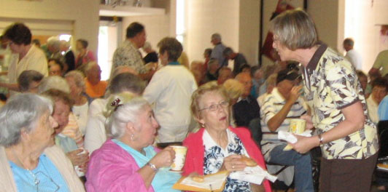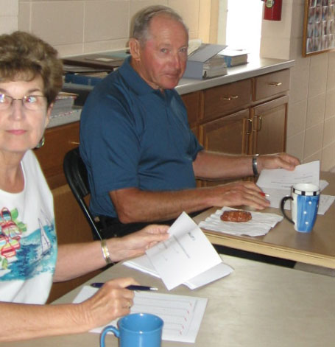

Annual Meeting

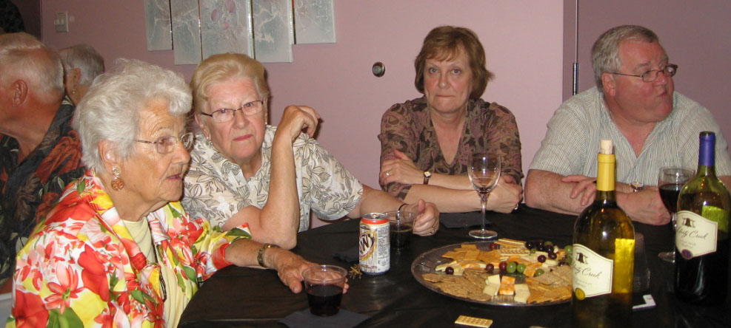

Sip & Sing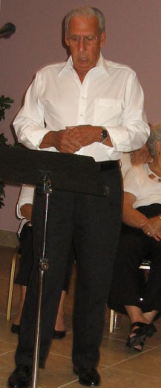 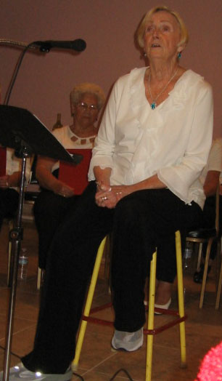
APRIL  
SUN.   | MON. | TUES. | WED | THURS | FRI.  1  BINGO 7PM | SAT.  2  HOMEOWN-ERS COFFEE HOUR 9AM
3  HYMN SING  6:45 PM | 4  BINGO 7PM  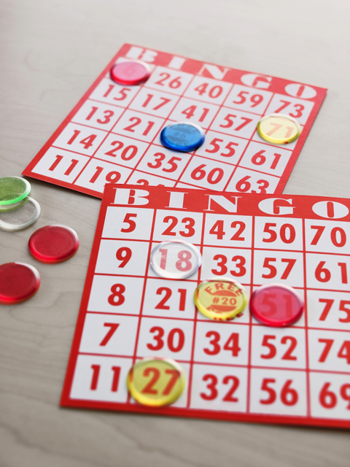 | 5  PINOCHLE  7PM | 6  BOARD MEETING 9:OOAM  ANNEX | 7  CARDS  7PM  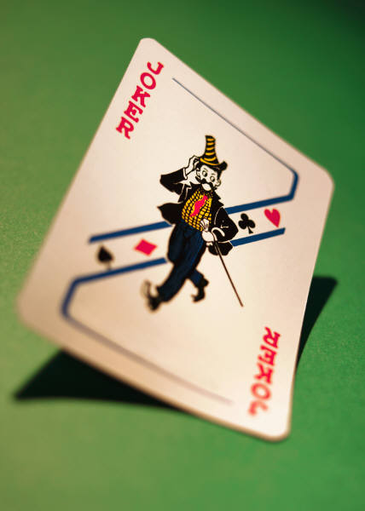 | 8  BINGO 7PM  ILL/WISC/  IOWA  LUNCHEON  11:30AM | 9
10  HYMN SING 6:45PM | 11  BINGO 7PM | 12PINOCHLE 7PM  IND BKFST  9:00AM  OHIO DINNER  4:30PM  MICH LUNCHEON  11:30AM | 13  PA/WV/MD  LUNCHEON  11:30AM | 14  CARDS 7PM  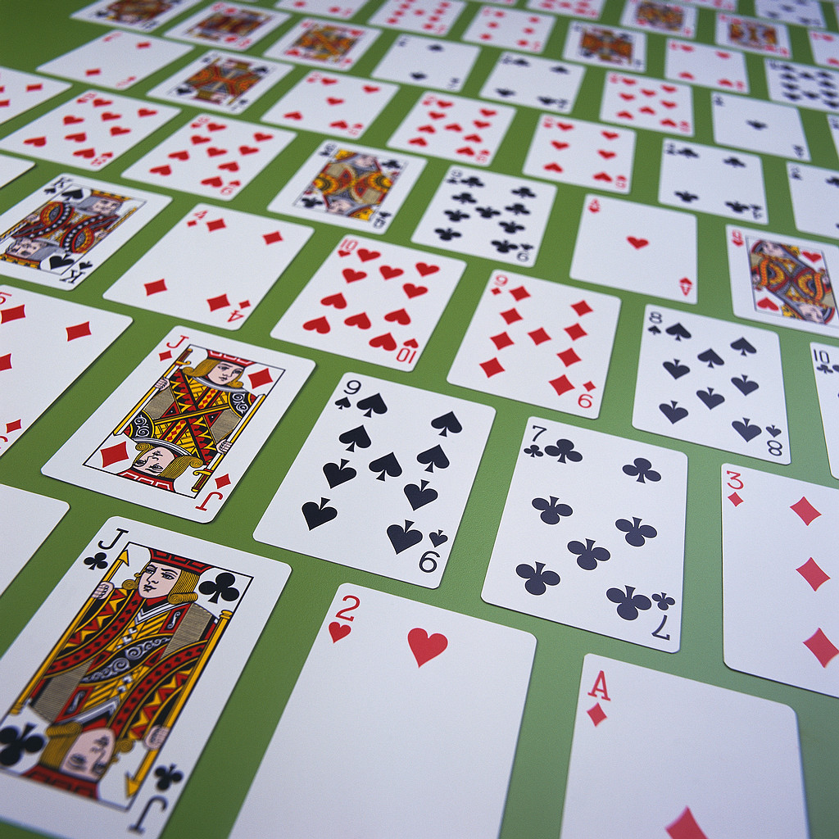 | 15  BINGO 7PM   | 16  REC CLUB  COFFEE HOUR 9AM  
17  HYMN SING 6:45PM | 18  BINGO 7PM  Passover begins | 19  PINOCHLE 7PM | 20 | 21  CARDS 7PM  NORTHEAST  LUNCHEON  11:30AM | 22 | 23  
24  HYMN SING  6:45 PM  Easter | 25  BINGO 7PM  BREEZE  DEADLINE | 26  PINOCHLE 7PM | 27 | 28  CARDS 7PM | 29  BINGO 7PM | 30

