November 201 0 volume 11
The Breeze 
HAPPY THANKSGIVING

THE PREZ SAYS…
____________________________________________________________________
It is great to be back in South Winds! The weather is approaching perfect and it is so nice to be among friends and neighbors again. Our hearts go out to the families of those we have lost over the summer and we send healing energy to our friends who are experiencing illness or suffering through treatment in hopes of recovery.
Your board is eager to move forward with plans for improvement of our park. As I mentioned at the board meeting, we need input as to the replacing of the existing kitchen. Those of you, who prepare and serve meals, please share your comments and recommendations with board members.
______________________________________________________________________

FROM THE EDITOR

Hurrah, I’ve arrived back in Southwinds and am ready to work on the Breeze for the month of November. Last minute, as usual, but with help again I’ll try to let you know what is happening, or has already happened. Thanks to those of you who have given information to me. For the next 6 months you may contact me at 244 Southwinds, by phone, 927-1212 or preferably by email - Smithbangelic2@aol.com.

Board Meeting
NOVEMBER 17, 2010

MICHIGAN FEEDS SOUTH WINDS

Thanksgiving Dinner is being hosted by our Michigan residents this year. They have been hard at work preparing the feast for all of us. Festivities will start with a social hour at 1PM and dinner to be served at 2PM.
Cost to the residents is $8.00 and guests $15.00. Bring your own place settings plus beverage of your choice to socialize with your friends and neighbors before dinner.
Tickets are available from Don & Shirley Langlois - #119, Ellie Eichler - #150, Francile Huser - 252, Smitty & Mamie Smith - #181, and Lee & Joyce Minges - #174.

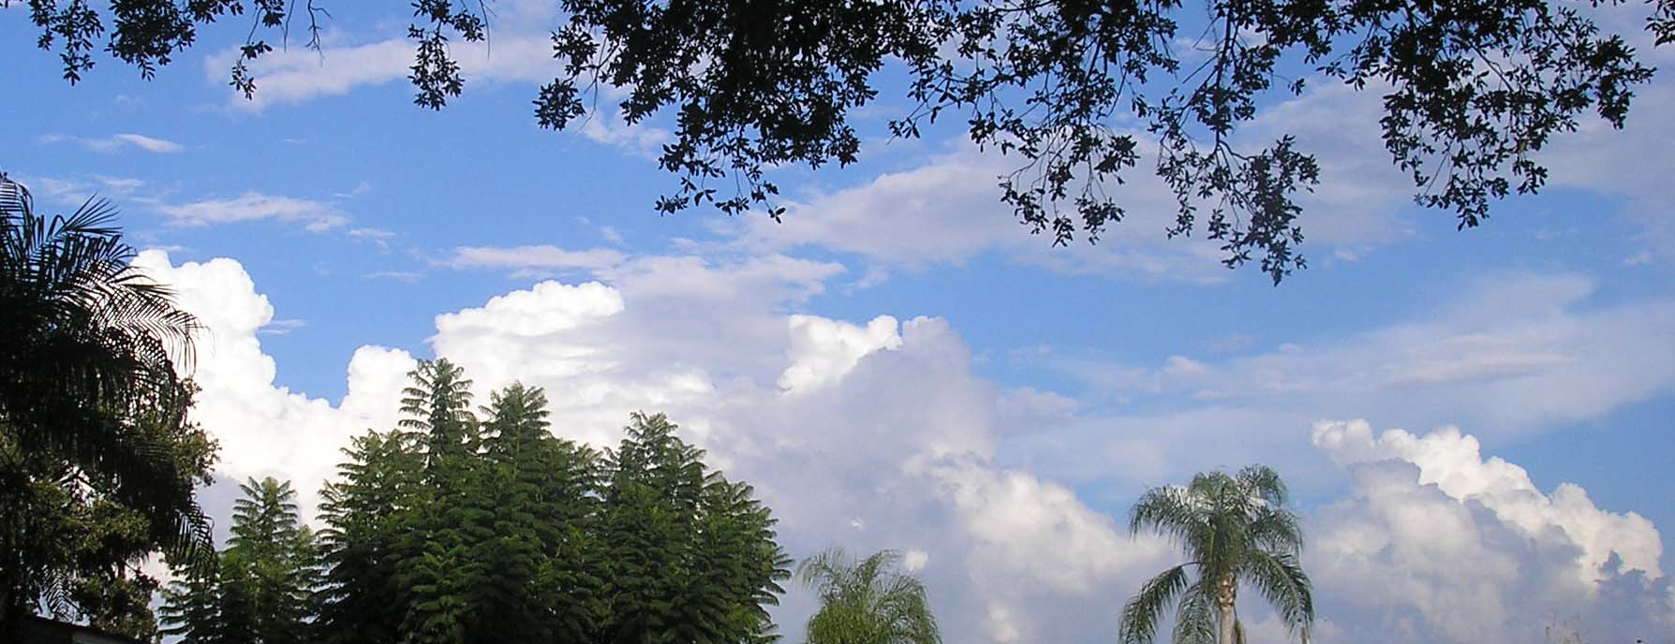

CLOUD NINE

Linda King & Bernie Coulter would like to invite all ladies from the park to come to Rec hall on Monday, November 8, 2010, at 12 noon for the annual Cloud Nine salad luncheon. Please bring a salad to share for the buffet. Also, bring your own plate and utensils.
VOLUNTEERS NEEDED
As we all know, this park is run by volunteers. If you can help in any way, we would sure appreciate your service. Without you, the park cannot operate, so think about what you can do to help keep the park running, and the activities happening.

At the November 20th Coffee Hour, the Rec Club will be presenting the following nominee(s) for the off of Rec Club President:
John Lockett and anyone else who wishes to volunteer.
We are also looking for a volunteer for 2nd Vice President.
Elections will be held at the December 18th Coffee Hour.
If you would like to volunteer for either office, please contact
Carol Bond c007bond@verizon.net 941-266-2124 or
Linda Honea hlhonea@verizon.net 941-921-4790

A BIG HAPPY BIRTHDAY WISH TO BERNIE ZIOLKOWSKI ON NOVEMBER 20. HAPPY BIRTHDAY FROM ALL!!!!!

LET’S EAT

Yep, it’s that time of year again!!! Time to get together with old friends and to make some new ones. Make sure to make your reservations.

The Pennsylvania group is meeting at DeMarco’s Restaurant on Clark Road on Wednesday, November 10, 2010 at 9AM.
Signup sheet on the bulletin board. For information, contact Windy Coulter - 927-9816.

Michiganders will meet on November 9th at 9AM at Troyers Dutch Heritage Restaurant. They also have a signup sheet on the bulletin board.

IN MEMORY

We again have lost two special residents of our Southwinds family.

Lenora Holloway, #98, passed away after an extended battle with cancer. Our condolences go out to her immediate family and also, her Southwinds family. Condolences can be sent to her daughter Paula Schortgen, 6875 N 300W, Hartford City, IN 47348

Peggy Beaule also lost her battle with cancer in October. She will be sorely missed by her husband and sons and again her Southwinds family. Condolences can be sent to Armand at 194 Southwinds Drive.

GET WELL NOW

Have heard from George Nehyba, #141 that he has a diagnosis of lymphoma and has been receiving chemotherapy after a regimen of radiation. Is hoping to be here in December or January.

Pauline Freda is also under treatment for cancer and hopefully will have good news and be able to come south for the winter. Her address is 143 Theresa St., Fitchburg, MA 01420

Bill & Susan Murray are both having medical problems and could not come down last year. If the doctor gives his OK, they will be here in November.

From the bulletin board I see that Ruth McConnell is doing better and hoping to be home soon. Her address is Box 402, Middlefield, Ohio 44062. I’m sure she would enjoy hearing from any and all.
Another message from Joanne Adam expressing regrets that they won’t be able to return to the park again this year and would love to hear from you. Her address is 371 Stillwood Drive, Kent, Ohio 44240
Also, her mother, Julianne Reich, #53, is recovering from spinal surgery and hopes to be down in November.

Have talked with Pat Merz and she tells me that Jim is doing well but doesn’t have a lot of energy after his bouts with radiation, and now chemotherapy, battling a couple of spots on his lungs. Their address is 593 Belvidere Ave., Columbus, Ohio 43223


STRETCH CLASSES WITH PAT MERZ WILL NOT BE HELD THIS YEAR DUE TO JIM’S ILLNESS. I UNDERSTAND THERE ARE TAPES AVAILABLE AND IF ANYONE WILL STEP UP AND ASSUME LEADERSHIP, THE CLASSES CAN STILL BE HELD. I KNOW HOW GOOD THESE EXERCISES ARE AND WOULD LIKE TO SEE SOMEONE VOLUNTEER TO CONTINUE WITH THE TAPES OR PROVIDE THEIR OWN PROGRAM UNTIL PAT IS ABLE TO CONTINUE, SOME TIME IN THE DISTANT FUTURE.

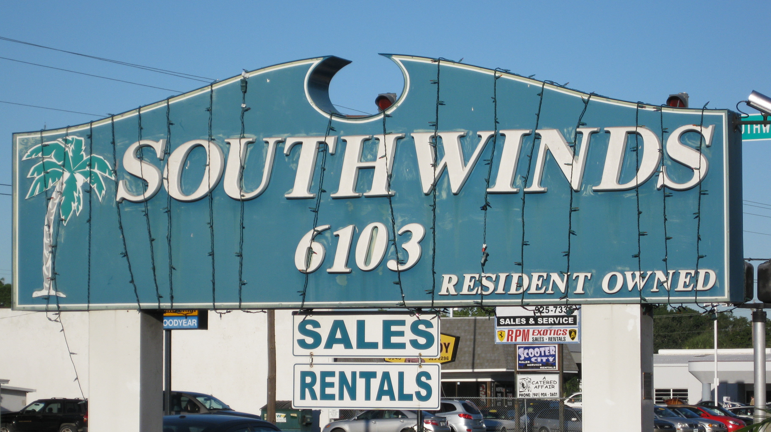
SOUTH WINDS CARES

Over the summer a new program was established for the safety of our residents. This program is essentially set up for those of you who live alone but can be used by anyone. It provides a buddy system to assure that if you are in need of help and have not been able to contact someone that the buddy will be checking on you every day and making sure that everything is OK. I urge each of you to consider your circumstances and think about becoming part of the program. This will be discussed in detail at the November Homeowner’s coffee hour and a signup sheet will be provided.



For all that has been – thanks
To all that will be – yes

Dag Hammarskjöld – Markings

