January 2011 volume 13
The Breeze 

HAPPY BIRTHDAY BREEZE

Prez Says…

Pennsylvania, Christmas dinner was marvelous. Thank you Barb Smith and wonderful volunteers!!
Thank you Barb Smith for resurrecting the Breeze and making it a huge success. I add my “birthday” wishes. We thank Joani Regner for her contributions to the Breeze as well. And, of course, it is only as good as the participation of residents who keep us informed of activities, illnesses and deaths and what is going on in their lives. So, continue your sharing of information to keep the Breeze the wonderful informative piece that it is.
It is the time of year to look forward to the Annual Meeting. Please submit your name for one of the three board openings and any items that you would like to see on the agenda. The first letter will go out next week. The park is as strong as its leadership and the residents who participate.
Happy New Year from the Board of Directors and best wishes for a healthy and prosperous 2011.

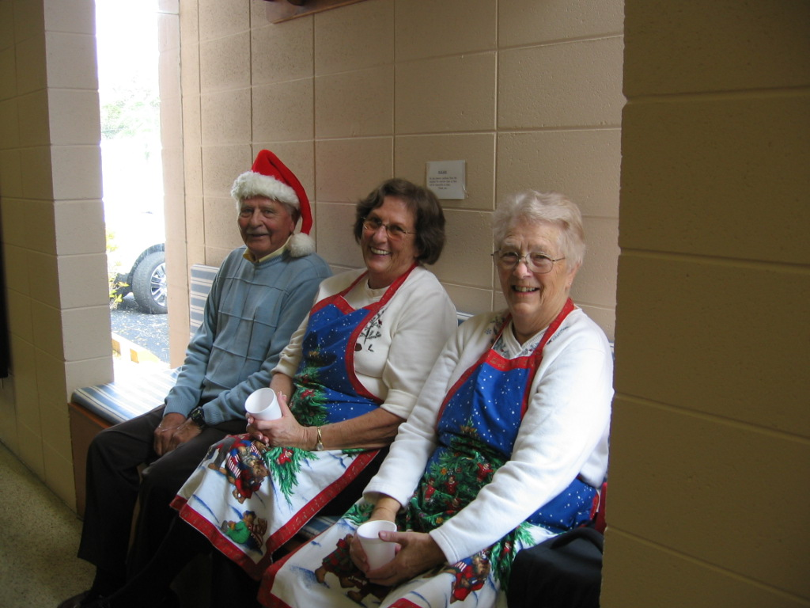Christmas Dinner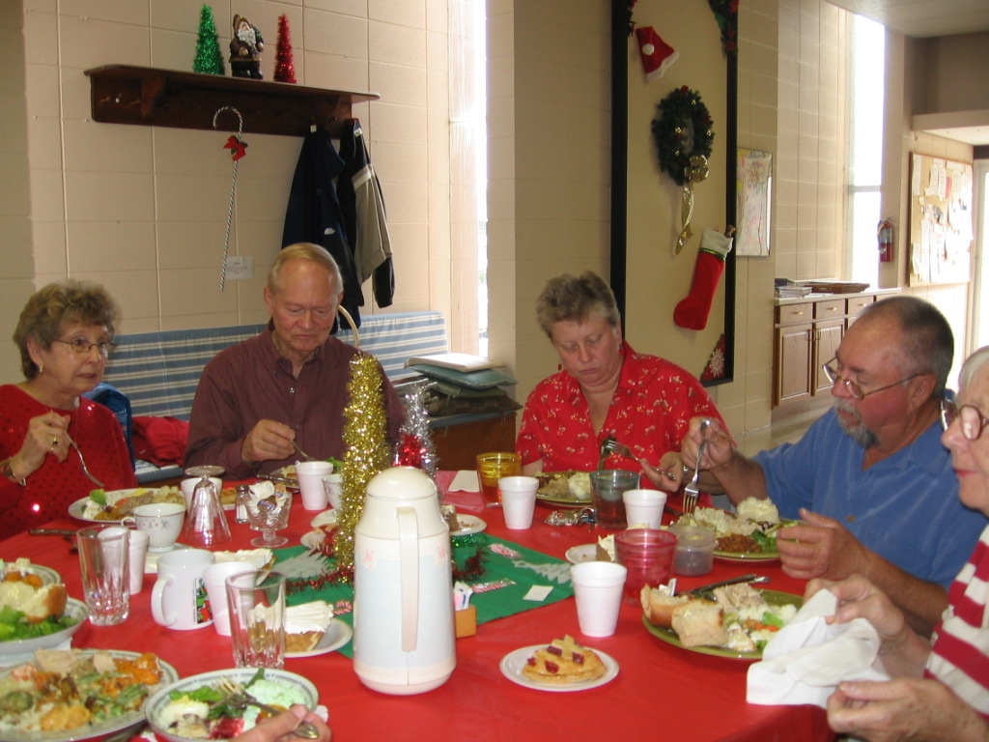

As co-chairman of the Christmas dinner with Audrie Ryan, I want to thank my committee for the great job they did for the Christmas dinner. It was sponsored by your friends from PA, WV, & MD. We are a small group and had to ask for a little help. Thanks to you who offered that help. It was appreciated. The food was delicious and plentiful; a good time was had by all. Merry Christmas again and have a blessed New Year. Barbara Smith

FOOD BANK REPORT
A special thank you to the many people who helped the less fortunate by contributing to “ALL FAITH’S FOOD BANK.” You responded with many high protein items (peanut butter, tuna, Spam, etc.), also some cookies and candy, as well as miscellaneous canned goods. We delivered 235 pounds of food. However large or small, every contribution means a lot to someone who is hungry and in need!!
Thanks again and HAPPY NEW YEAR!!
Shirley Langlois
Shuffleboard News 

The first league competition will be on Tuesday, Jan. 4 at 1 PM against the Vista team. Come cheer our team on!! Also, watch for announcements of lessons which will be scheduled soon and pick up some useful tips, strategies, rules, etc. Discover just how much fun shuffleboard can be.

 HOBBY CLUB NEWS

The new season for the Hobby Club will start on January 17th at 9:30 in the Annex. Madeleine Ferraz will again be giving water color lessons beginning Jan. 31st.
Christmas gifts were provided to 6 shut ins, thanks to the members.
Please watch the bulletin board for further news on projects, etc.
Pauline Villeneuve

From your editor:
I want to welcome all our January Snowbirds back from the North. For those of you who are renting; please enjoy all the different activities the park has to offer. Hope you left the cold weather up there; we’ve had enough for this season.

Also, I’d like to make a comment about volunteers in the park. This is a 55plus park. To be so designated, we must provide a certain number of activities, which are run by volunteers. We do have some great volunteers. However, we need more people who are willing to lead an activity, help with the different management aspects, etc. . Remember, this is our park, not yours, his, hers. or theirs. We are all responsible for seeing that it runs well. We do not want to lose our 55plus status.

Thanks to those volunteers who made the park look so festive for the Christmas season. Every year we have a dedicated group of people who see that the front of the park is decorated, the hall is decorated and the Memorial Tree is put up. Thank you, each and everyone, for putting us all in the holiday mood.

My last comment is about the turkey that was taken from the freezer in the Rec Hall. I have heard a few rumors but have nothing concrete at this time to tell who took it. That freezer is to be used for the different functions that happen here in the park. It is not for personal use, so anything that is in it belongs to the activity for which it was purchased. Whoever stole it, took it from each and every one of us. I hope it doesn’t ever happen again.



January 12, 2011 in the Annex. 9:00 a.m.



WANT TO BUY A COMPUTER?

Then come to the South Winds Hobby Club Computer seminars. If you feel that you have a need for basic computer education,
or have questions about computing, then come on down.

January 13, 2011 at 2 PM in the Rec Hall
PART I. Computer systems Basic Discussing hardware components, choices, necessity
Useful information if considering buying or upgrading

January 27, 2011 at 2PM in the Rec Hall
PART II. Software Systems
Discussing operating systems, application programs,
Such as Internet, pictures (Google’s Picasa) Word
Processing, Printer functions, DSL and
New Era (HDTV) TV functions.

Sign up sheet will be on the Rec Hall outside bulletin board starting Jan. 2, 2011 or call 924-8549. See you there.



Break the Winter Blues Party

Jan 22, 7:30 to 11:00 P.M.

$8.00 per person at the door

Music by Double Density

BYOB and snacks for your table

Don’t let the nip in the air keep you from having a fun filled evening of dancing. Warm up with good friends and great music. Everyone is welcome. Info, Pat 922-5030

ALL STRETCH CLASS PARTICIPANTS!!!!!!

TO MAKE ROOM FOR OVER 1000 NEW 45 CDS FOR THE JUKE BOX, WE WILL BE MOVING STRETCH CLASS MATS FROM THE CUPBOARD BY THE EAST DOOR OF THE REC HALL. THEY WILL BE PLACED IN A BOX IN THE STOREROOM ON THE WEST SIDE OF THE STAGE. IF YOU WOULD PREFER, YOU MAY PICK UP YOUR MAT TO KEEP AT HOME.

DINING OUT 

The CANADIANS are having a Happy Hour Supper at 4PM on January 7, 2011 at the Dutch Valley Restaurant, 6721 S. Tamiami Trail.
Sign up sheet on bulletin board
Hostesses: Verna Sanderson
924-3226
Persus Moyaert 921-7889

ILLINOIS-WISCONSIN-IOWA
Your luncheon will be held Jan. 14th at 11:30AM at Legacy Grille, 6606 S. Tamiami Trail.
Sign up sheet on the bulletin board
Info: The Kidd or Claire 024-1145

The OHIO group will have a breakfast buffet on Friday, Jan. 14, at 9AM at Troyer’s Dutch Heritage, 3713 Bahia Vista St.
Sign up sheet on the bulletin board
Questions? Manton - 921-6844

PA, WV, AND MD are having a luncheon at OPHELIA’S PASTA HOUSE, corner of Rt 41 and Laurel Rd., on Wednesday, Jan 12, 2011 at 11:30 AM.
Sign up sheet on the bulletin board.
Don’t forget, you can stop and shop at Wal-Mart after eating. Happy New Year to y’al. Windy 927-9816

The NORTHEAST luncheon will be held January 12th at 11:30 AM at Millie’s Café, 3900 Clark Rd.
Info: Gerry Kochan 924-0892

AS OF JANUARY 1, 2011, THE CHORUS WILL MEET ON WEDNESDAY AT 9:30 IN THE REC HALL, NO LONGER ON MONDAYS.

HYMN SING 

Every Sunday evening at 6:45 Hymn Sing is held at the Rec Hall. Volunteers are needed for MCs and for special music. If you can play the piano or organ or would like to do special music, please contact John Butler at 926-3495. Also, on the second Sunday of each month an ice cream social is held, so come join in. Everyone is welcome.

CLOUD NINE 

On December 13th, a cookie exchange and Yankee swap was held by the Cloud Nine member. Cookies were wonderful, gifts were fun, and a good time was had by all. Each member took home a plate of homemade cookies and the rest were divided and given to the shut ins. We have some fabulous cooks in the park. I know ‘cuz I was there.

CLOUD NINE TOO 

On Monday, Jan. 10, 2011 at 11AM there will be a guided tour of new and redecorated Southwinds Home…Then right back to the Rec Hall for TEA with a light lunch. Wear your fanciest hat.Prizes will be awarded!!!
Cost is $3.00 per person.
Additional info: Celeste Mosher 941-993-9535 or
Shirley Sweet 942-924-7208
A sign up sheet is on the bulletin board.

EATING AGAIN!!! 

There will be two pot luck dinners in January.

The first one will be held Jan. 12 at 5:30 with entertainment by Don Fangman singing Frank Sinatra hits.

The second one will be Jan. 26 at 5:30 also. Entertainment this night will be by Joe Garafalo, sax and clarinet.

There will be a CHILI DINNER, in between the two pot luck dinners. It will be on Jan. 19 and is sponsored by the Rec Club. Tickets are required. This is a fund raiser for the Rec Club so that they may continue to provide all the fun functions that happen over the course of the year. More information will be available on the Video Breeze and also on the bulletin boards at the Hall.

SEE YOU THERE!!!

BIRTHDAYS 90 AND OVER
Sybill Storrs - January 23

I have no listing for anniversaries over 50 years for Jan. If you have one coming up. Please let me or Smitty know and we will acknowledge it.

FOR YOUR INFORMATION
FLORIDA DRIVER’S LICENSE CHANGES

Florida has new documentation requirements for renewing or obtaining a driver’s license or identification card. Below are the most common documents accepted. Other types of acceptable documents can be found at www.GatherGoGet.com.

1. Identification
A. U.S. citizen (certified birth certificate, valid U.S. passport)
B. If applicable, proof of legal name change (certified marriage certificate)
2. Social Security Number (social security card, W-2, 1099 or pay check/stub showing complete number)
3. Residential Address - not PO Box - must bring two documents (deed, monthly mortgage statement, car or vessel registration/title, recent utility bill, voter registration card, W-2 or 1099)

ON THE MEND 

Ellie Eichler, Joyce Dame, and Harold Davies have made trips to the hospital but all are home now.

MORE CHRISTMAS


