The Breeze volume 8 August 2011 

THE PREZ SAYS…

I send kudos and many thanks to Bernie and Windy Coulter and their committee for providing the excellent Fourth of July event. Special thanks to Dave Friedlein for the presentation and to Paul Rodriguez for the beer. It was great to be in the park and participate. Unusual has become the norm for weather this year as, all over North America, folks are sweltering in extreme heat or suffering floods or drought. We wish everyone safety from the elements. The sun shade, at the pool, has proven to be a more complex issue than anticipated and will be dealt with after the Board returns in the fall. Other park projects, maintenance and office, are right on target. It won’t be long before we start returning. Until we see you, enjoy!

The Statue of Liberty cornerstone was laid in August 1884.

GOT WELL 

A NOTE FROM YOUR EDITOR
I want to thank each and every one of you who have kept me in your prayers and thoughts as I recover. Thanks for all the cards and emails. I do appreciate them.
I had an ulcer that penetrated an artery and lost a lot of blood. Thanks to my family and the ambulance crew I was gotten to the hospital in time, although they couldn’t find a pulse or a blood pressure. I was given 4 pints of blood and a unit of platelets. Next morning they did a scope, at which time they removed the ulcer, clamped and cauterized the artery, and I was on my way to recovery. I am feeling very good and my blood

counts are all back in the normal range.
Isn’t modern medicine wonderful!!!!! Sometimes we think that all the doctors and hospitals do is make mistakes and take our money. The media really plays up on that idea. I am here to tell you that for every mistake that is made, thousands of correct diagnoses are made and thousands of lives are saved. Walt and I are both living proof
that good care is given most of the time.
Thanks again to all of you and to Joani who covered for me last month on the Breeze.

CELEBRATIONS 

Looks like we had no 90th birthdays or 50th anniversaries in July. However, here comes August. Congratulations to all of you!!!

Happy 97th Birthday to Bill Hagan!!!!

HAPPY ANNIVERSARY

Larry & Elsie Green – August 2, 1958
Glen & Marilyn Tranbarger – August7, 1949
Byron & Shirley Powell – August 8, 1953.
Ray & Pauline Villeneuve – August 8, 1958
Art & Joyce Marvel – August 19, 1955
Mel & Noreen Deming – August 21, 1943
Pat & Jean Harwell – August 24, 1957
Bill & Tish May – August 30, 1951

Will Rogers WIT & WISDOM

Again I’d like to give you some of this man’s famous advice. Next month, I will print his wisdom of growing older.

NEVER MISS A GOOD CHANCE TO SHUP UP.

THE QUICKEST WAY TO DOUBLE YOUR MONEY IS TO FOLD IT AND PUT IT BACK INTO YOUR POCKET

LETTIN’ THE CAT OUT OF THE BAG IS A LOT EASIER ’N PUTTIN’ IT BACK

NEWS FROM SARASOTA 

I want to thank Francile for updating us on some of the happenings in Sarasota over the past few months. She sent me some of this info for the July issue but will include it all in this issue due to my illness.

Ten new red light cameras being installed – violators will be fined $158 for each light running offense
Meters in the downtown area affected by humidity, especially in the morning – now covered and not being used
New, North, “Rooms to Go”
Wachovia Bank now “Wells Fargo”
Kennedy Central (D.C.) selected Sarasota over seven other Florida and US cities for a national program aimed at expanding Arts Education in Elementary and Middle Schools.
Bacon’s Furniture Store (south) moving to the empty Robb & Stuckey Bldg.



Also from Francile 

Talked with Laverne Detweiler who was in the park visiting. He missed the park so much; he told his wife “I am getting homesick for South Winds so I am driving over there”. Was surprised and appreciated all of the cards from SW residents. They gave him a boost in life.

FROM THE LIBRARY

Just a note to remind those of you who may have taken books home to read for the summer, please bring them back when you return to Southwinds. Currently, we are missing a lot of the large print books that were donated for the library.

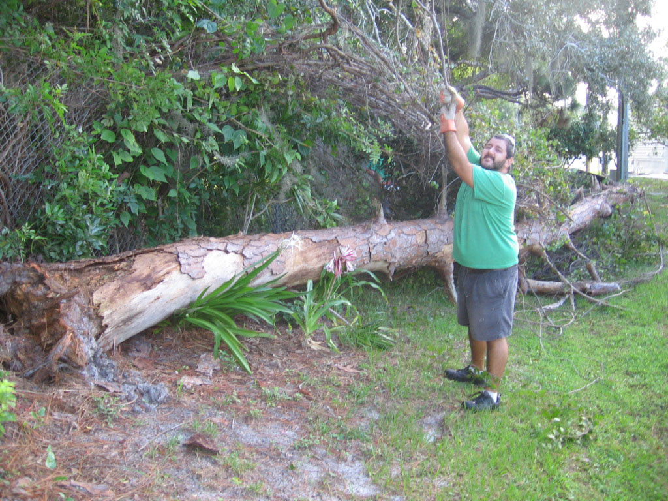
Tree fell behind 150 – no damage


We have lost another of our residents. Bernie Murphy passed away July 19 from a brain tumor. Our prayers go out to Teresa and their family.
Also, our prayers go out to Judy & Jerome Miller on the passing of Judy’s sister June on July 11.


I understand we have several people who are ill or have had surgery. Since no one has sent me this information, I am just sending a “GET WELL” wish to all of you. Hope you recover quickly.

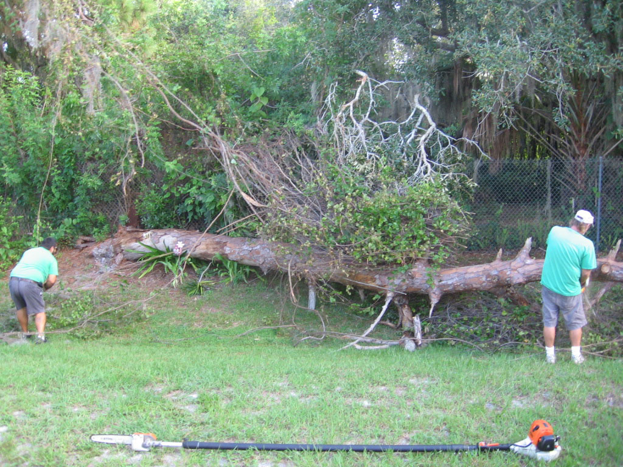

ANOTHER REMINDER 

As you have been told, the rental process in the park has been changed. Anyone who wishes to rent their place must get forms from the office before that rental can be made. Once, the approval is given, you may handle the rental by yourself, through an individual, or a real estate agent. This is the first year that the process is in place and there may be some confusion. If you are not sure what to do, just contact the office and the proper forms will be sent to you.
Please help us to implement the changes as the old way was illegal and had to be ended. Many, many thanks to the great committee: Dave & Sue Friedlein, Ellie Eichler, Ethel Hartnett, Gerry Kochan and Connie Vaughn who helped put on the 4th of July picnic. We had 58 residents attending, including 6 guests and 7 take outs.
Dave Friedlein obtained and showed a 45 minute video, “The Many Faces of Old Glory”, a perfect ending for our celebration of Independence Day.
Thanks to Paul Rodriguez for donating beer for the picnic – and to all who helped clean up. What a Country!

Windy & Bernie Coulter

MARK YOUR CALENDAR

South Winds will be having its free Labor Day luncheon on Monday, September 5th at 1:00 p.m.
Guests - $5.00
Please sign up by September 1 and be prepared to sign up to help.

Annette Boettger & Gerry Kochan

 MOPS AUGUST

Wednesday, August 3, 11:30 a.m.
Stoneybrook Golf & Country Club
8801 Stoneybrook Boulevard

Wednesday, August 17, 11:30 a.m.
Gator Tails
8383 South Tamiami Trail

CAN YOU SEE ME NOW?

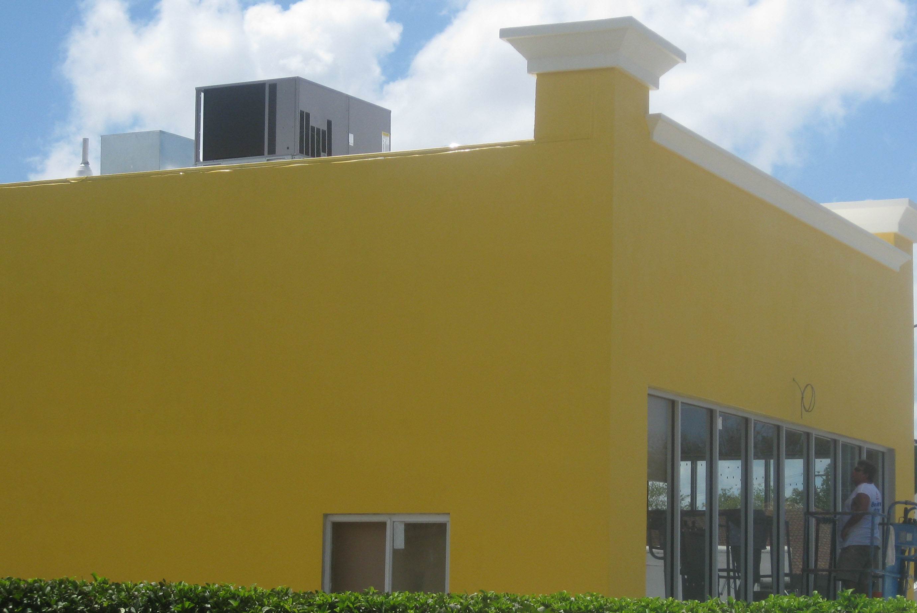 Progress next door

