November 2011
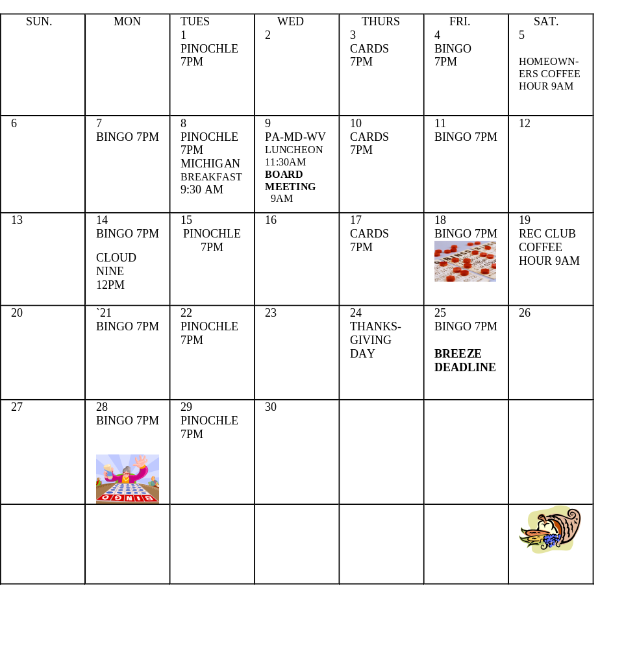
The Breeze volume 11 November 2011 

THE PREZ SAYS…
The park is alive with the voices and activities of our returning friends and neighbors. It is good to be in the warmth and sunshine of Sarasota. We hold in our hearts those residents who lost loved ones this year. We assure you that you can count on your friends and neighbors at South Winds to give you any support that you might need. We are family.

As you read on, you will see that the celebrations have begun. We will share meals, cards, bingo and many other activities.

We have had our first board meeting and the next will be on Wednesday, November 9th. There is much important work to be accomplished and the board certainly welcomes your input.

Welcome and enjoy!


 MICHIGAN PASSES THE THANKSGIVING
DINNER TORCH TO CANADA 

CLOUD NINE (first event of the season)
Salad Luncheon with a Beach Ecology presentation by Dr. Alan Worms.
Monday, November 14, 2011 at 12pm at the Rec Hall
Members and guests are welcome
Please bring a salad to share for our buffet. Bring your own plate/utensils

Hostesses: Evelyn Coleman and Carol Proteau


How would you like to know what is socially happening in your mobile home park?

The Rec Club is currently accepting nominations for the following officers.

President
2nd Vice President
Secretary
Asst. Secretary
Asst. Treasurer

The elections will be held at the December Rec Club Coffee Hour. The elected officers’ terms will begin on Jan. 1, 2012

Please submit your nomination to Linda Honea @ 921-4790 or email to hlhonea@verizon.net

The Rec Club is currently seeking a replacement for Sharon Currie as our Entertainment Director. The responsibilities include arrangement for the entertainment for the 6 Potluck Dinners and one Special Entertainment per season.
Sharon has done a great job for the past several years and has it very well organized and is more than happy to train you. Please contact Linda Honea @ 921-4790 or email to hlhonea@verizon.net to volunteer.

We need volunteers for coffee hours. Signup sheet located in the Rec Hall on the southwest bulletin board.
The Holiday Season is upon us. This year our Thanksgiving Host is Canada and the Christmas hosts are IL, IA, IN, & WI. Again, contact Linda Honea @921-4790 or email to hlhonea@verizon.net for additional information

The Rec Club wants to send big THANK YOU to all of our VOLUNTEERS past and future. You make our park what it is and we could not function without all of you.


 DINING OUT

MICHIGAN BREAKFAST @ MILLIE’S
3900 Clark Road
November 8, 9:30 AM
Come on and let’s get re-acquainted – guests are welcome!!
Signup sheet on the bulletin board
Questions?
Call Shirley Langlois 922-9547

NEXT BOARD MEETING, WEDNESDAY, NOVEMBER 9, 2011 9AM ANNEX

PA—MD—WV—LUNCHEON
MILLIE’S
3900 Clark Road
Wed., Nov. 9, 2011
11:30 am
Welcome back, everyone. Let’s all get together and do what we do best----EAT
Signup sheet on bulletin board

Windy Coulter 3158c
927-9816


COMPUTER CLUB

Computer Startup 101
-For any individual who has or contemplates purchasing a computer, desktop, notebook, or laptop.
-Covers first things to do when you get it home,
-problem recovery perpetration
-Control panel overview
-Windows Explorer overview
-Internet Explorer & Internet service
Providers (ISP) overview
-Discussion of components-internal/external
-Suggested free & useful software for security,
Adobe Reader, MS notebook (word processor)
-Question & answers (answers were possible)

Windows Explorer
-The tool to find what’s in and about your computer
-Directory structure
-Define/rename/move/copy folders & files
-Identify external drives, e.g., hdd, sticks, rename
-Define & use of administrator, user, guest

Word Processing
-Open, construct and close a MS word processing application known as
WordPad & is a component of Windows. -E mail attachments & Adobe pdf overview
DON’T FORGET THE THANKSGIVING DINNER. IT WILL BE HOSTED BY THE CANADIANS. DON’T HAVE ANY DETAILS AS OF NOW SO KEEP WATCHING THE VIDEO BREEZE AND LOOK FOR INFO ON THE BULLETIN BOARD



Photo Shop
-How to find and “read” photos from a camera into a computer, & find them
-name, rename one or more or all Picts.
-How to scan Picts into Windows Explorer
-Discussion of multi photo applications, all free

Individuals are welcome to one or all meetings. Present plan is to hold class in the Annex with a 9 AM start time. The exact day will be selected at a later time. The space in the Annex is limited, so you are requested to advise your choice of class.
Please contact me by phone (941-924-8549) or visit me in our park.
DEATHS
Two residents have died and we will miss them greatly.
Charlie Goodwin – Our sincere sympathy to Carol Kachlic. Steve Adam died Oct. 23, 2011. Condolences to his wife Joanne and their family.

Have heard of the deaths of 2 former residents also. Eunice Sheehan died this past April. Pete Driscoll, formerly of Unit#149 passed away on Oct. 21, 2011.
CELEBRATIONS

WE HAVE NO 50TH OR MORE ANNIVERSARIES THIS MONTH.
ALSO, HAVE NO 90 AND OVER BIRTHDAYS FOR THE MONTH.
IF YOU HAVE BEEN MARRIED 50 YEARS OR MORE, PLEASE LET BARB SMITH (927-1212) KNOW FOR THE BREEZE OR SMITTY (923-3932) FOR THE VIDEO BREEZE
From Maintenance

Please turn off lights and fans in the Annex after your event.
Do not bring garbage, small appliances or construction materials to the maintenance shop. Put these items out in front of your unit on collection day. You can call for large appliance and maintenance will pick them up.
Please DO NOT un-screw the floodlights at the pool.

