THE BREEZE November 2014

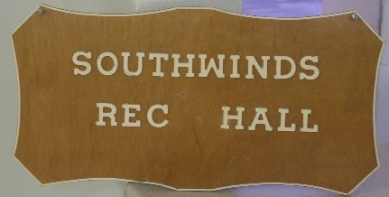

It’s a new season and with it comes more special times here in the park!!!!
Have you been to see the new additions to the hall? They’re really fabulous and we all need to say thank you to ourselves because without our homeowners’ approval this would never have happened. We really need to say thank you to Mike Currie for overseeing the build, buying new appliances, and trying to keep things on schedule, all from his home in Nova Scotia. Don’t tell me that the directors don’t work over the summer. How many phone calls do you think he made in the past months?? A second thank you to Jerome Miller, our Treasurer, who spends so many hours managing our budget, and was able to show us how this could all be financed with no increase in maintenance fees. My last thank you is to park maintenance and office for all of the extra effort they’ve been giving, in addition to their usual daily chores. These improvements will serve the park well for many years to come.

Stage Bench seats

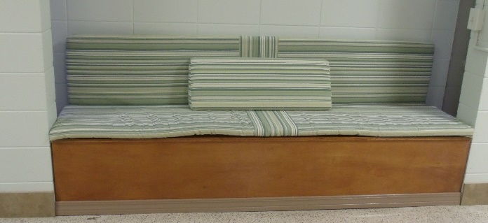

Kitchen Women’s bathroom

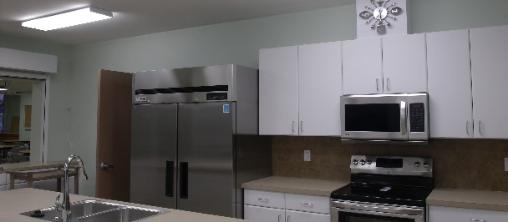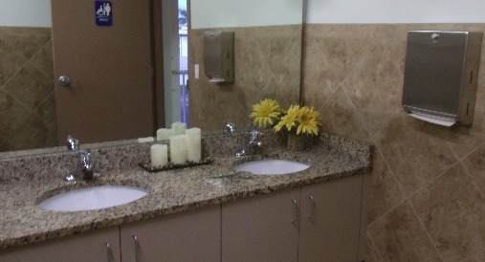
ATTENTION: Cooperative Directors, Director Candidates, and Unit Owners

Are you now a director?? Do you think you might like to be a director?? Florida’s Cooperative Act requires individuals who serve as Directors of their associations to meet certain educational requirements, specifically F.S. Chapter 719.106(1)(d) 1.b. Candidates must complete the educational curriculum administered by an education provider within 1 year before or 90 days after the date of election or appointment.
Florida Resident Owned Communities, Inc. (FLAROC) is offering a training seminar on Thursday, December 4, 2014, at Oakwood Manor beginning with a sign-in at 8:15 am.
Each participant will be awarded a Certificate of Completion proving compliance with this statutory requirement. There is no charge to the participants

PA--WV--MD LUNCHEON

GECKOS GRILL & PUB
5585 Palmer Crossing
(Clark Rd. behind Applebee’s)

Wednesday, November 5, 2014
11:30 AM

Welcome back y'all and looking forward to see all your smiling faces for our first luncheon of the season. Signup sheet on bulletin board in annex.

Windy Coulter, #158C
927-9816

SATURDAY, NOVEMBER 1ST – COFFEE HOUR, 9AM
SATURDAY, NOVEMBER 15TH – COFFEE HOUR, 9AM
WEDNESDAY, THANKSGIVING DINNER (tickets required)

“The Hall” Bulletin Board wall
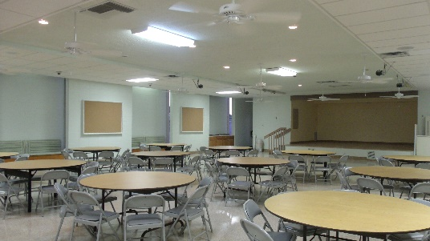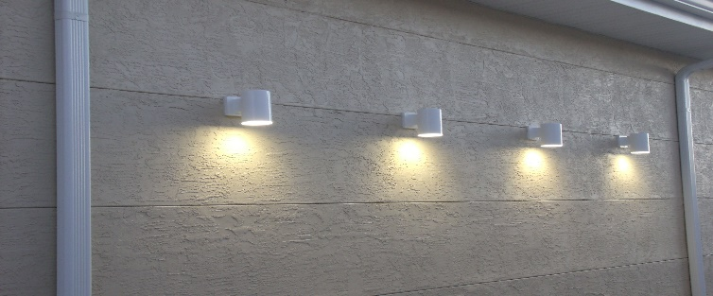
OUR SINCERE CONDOLENCES

This note from Suzy Summan:
Ruby Osborne passed away just 5 weeks after Bob and she was laid to rest Oct. 11. Her daughter had taken her shopping that week and she had been quite busy. But had been having heart trouble and had a few hospital visits.

Also a note from Ila & Vern:
We were in today to see the cancer Dr. The PET scan done on Friday shows the tumors on lungs are growing….went from 1.1 to 1.7 since July. He has been losing so much weight that the Dr. decided to have Hospice come out to meet us and set up so when we need them we are ready. Right now Vern has no problems with the lungs but Dr. thinks he will. His only pain is the hip/pelvic area and so far the Dr. has kept the pain manageable.
Love and Prayers, Ila and Vern

GOOD DEEDS ARE LIKE WILDFLOWER SEEDS,
THROW ENOUGH OF THEM AROUND AND A DESERT BECOMES A GARDEN

Flu Shots November 4
Annex, 9:00 a.m.

NOVEMBER, 2014 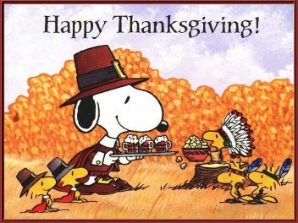

SUN | MON | TUES | WED | THURS | FRI | SAT  1  Home-owners Coffee Hour 9am
2 | 3  Bingo  7pm | 4  Pinochle 7pm  Flu Shots | 5  PA/WV/MD  Luncheon  11:30am | 6  Euchre 7pm | 7  Bingo 7pm | 8
9 | 10  Bingo  7pm | 11 Pinochle 7pm  Board Mtg | 12 | 13  Euchre 7pm | 14  Bingo  7pm | 15  Rec Club  Coffee Hour
16 | 17  Bingo  7pm | 18 Pinochle 7pm | 19 | 20  Euchre 7pm | 21  Bingo  7pm | 22
3 | 24  Bingo 7pm | 25 Pinochle 7pm | 26  Thanks-giving  Dinner | 27  Euchre 7pm | 28  Bingo  7pm | 29
30

