THE BREEZE Mar 2017 

SOUTHWINDS ANNUAL PICNIC
Annual Meeting

The Annual meeting for Southwinds’ residents is on Saturday, March 4th, starting at 8:15am. Please cast your vote for the candidates of your choice and return it to the ballot box in the office before the meeting. All other votes will be by voting cards, one to a unit. We have several items on the agenda. Hopefully, you have read the material in your packets and are prepared to listen to the proposals and make your decision.
REMEMBER- this is your park, don’t listen to gossip, get the facts!!! Your opinions matter and you do this by being well informed.

Come one come all
Yearly picnic to be held on March 18th at noon
Picnic hosted by the Purple Group (244-282)
Pick up tickets after the annual meeting in the annex.
Residents are free. Overnight Visitors are $8.00
Under 12 are $4.00

Board News for February
Meeting (2/7/17) called to order by Manton, all directors were present Minutes read & approved Treasurer’s Report-Crews - Financial reports are at the CPA’s office. All park owned units were inspected and are generally in good condition. Apt. #2 has been vacated, needed minor repairs, should be rented by March 1. Revenue to park for the year from rentals is $70,000 Maintenance: Dail – Survey results of Park maintenance: 93% checked better than or as expected, 7% less than expected or not observed Worked on: Unit #27 to ready it for new renter/leaky disposal in kitchen/sewer lines Bids being sought for some electrical work – Paving bids are underway Volunteers to clean up of park area on 2/14/17 from 1pm to 3pm Improvement Report : King: 5 units approved for upgrades/shared plans for new unit #137 Old Business: Manton Department of Business supports the law stating that the Board of Directors approves the budget unless the 115% trigger ensues. Letter is posted Voting/ annual meeting will be with a voting card, only secret ballot is for election of Directors Bocce Court: Dail – As no one is willing to be in charge, we will forgo until someone steps up Landscaping, Rec. Hall: Smith – Landscaper’s fundraiser netted $600 and Rec Club gave $400. Board approved $800 from the Memorial Fund to help with Rec Hall landscaping New Business: Ballot counting committee; Keith Damschroder, chair other members: Mary Ann Bender, Denise Bryant, Sharon Currie, Gloria Harrington, Mike Joyce, Marge Lothian, Rich Smith, Arlene Spears Caretaker: Approved Mike Cox request for caretaker status for his son, Scott, until May/2017
Meeting (2/21/17) -called to order by Manton -minutes read and approved – Treasurer’s Report: Manton reported that we were $2,084 better than budget Maintenance Report-Dail Paving will be done week 3 or 4 of April Improvement Report King #116/siding/same color - #241, palm tree between Lockett & Auten Old Business – Manton Checking TV system at Oakwood Manor/same as what is proposed for park
Board Input on Reduction of Directors – 7 yes, 1 no Audience Input-someone is using pool who’s not from the park/ will check Emergency exit/ no agreement with New Dynasty at this time (put on priority list)

 REC CLUB CALENDAR
Wed., March 1st – Bobby Palermo Sat.,March 4th – South Winds Homeowner’s Annual Meeting Wed., March 8th – Pot Luck Sat., March 11th – St. Patrick’s Dance Fri., March 17th – St.Patrick’s Parade Sat., March 18th – Rec Club Coffee Hour Sat., March 18th – Annual Park Picnic Wed., March 22nd – Pot Luck Sat., March 25th – Bye Bye BirdieDance

WATER USAGE
As we have all heard, water usage is one of our biggest expenses in the park. It's wonderful that we have this convenience in the picnic area. Let's not abuse it.
A message to residents and guests that are utilizing the water in the picnic area. Be sure to turn the water off when finished. Over the past couple of weeks, we have had a few instances where users have forgotten to turn off the water

St. Patrick’s Dance
Southwinds Rec Hall Sat. March 11, 7:30 Music by “Sonny and Sabel” $8.00 at the door B YOB and Snack for your table) Win our 50/50 Draw!

CLOUD 9 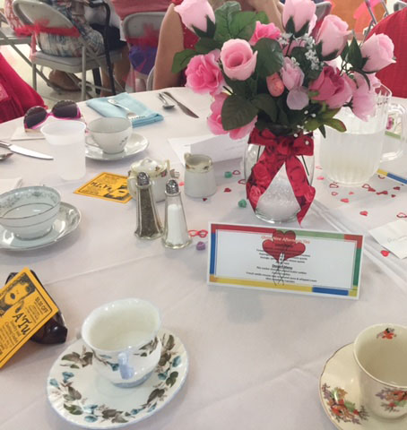
Tea, Lunch and Fashion Show, held on Monday, February 13th, was attended by 128 ladies! Everyone enjoyed a delicious lunch, fabulous tea, beautiful decorations and an awesome fashion show by A'Tu. New this year was the addition of 16 men from our park who not only served the ladies lunch but entertained them with singing of That's Amore for which the men received a loud round of applause. The Cloud 9 officers wish to thank the men who participated to make this event special and also the many members and guests who helped get this event together, from set-up to clean-up. Plans are already underway for next year's events. Our chef, Johnna Dail, has decided to "retire" from the cooking so Cloud 9 has an opening. If you would like to help plan, organize and get a team of cooks together for next year's luncheon please contact Jan Crews, or Johnna Dail.

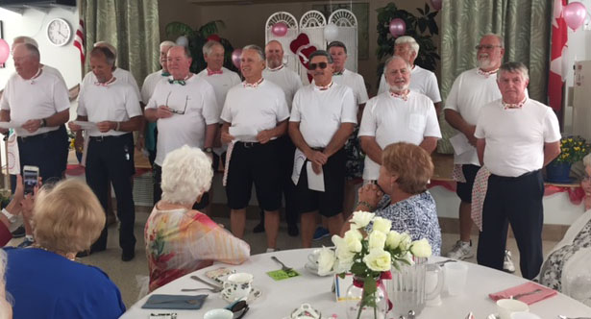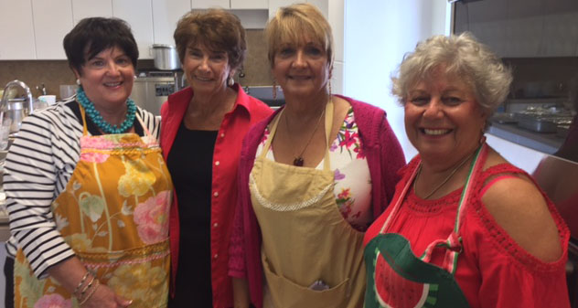

Cloud 9 Wine & Food Pairing – 6:30PM, March 21st - limited tickets: $15

The Recreation club would like to thank all the hard and generous workers. The first every Auction was a huge success. This year’s garage sale went smoothly and was even more profitable than last due to Joe's organization skills and ability to work with others. Our Breakfast gets better-- thank you David, waitresses, and clean up. Boutique-- great job as always, displaying and encouraging us to look great. Thanks for everyone's donations.

The Book Club will meet on Monday, March 13th at 1:30 in the Annex.
We'll be discussing "Sanibel Flats" by Randy Wayne White.
The final meeting for the season will be on April 3rd.
We'll be discussing "Me Before You" by Jojo Moyes.
Everyone's welcome!
??? Call Linda McGraw at 941-925-9874 or email at Linda943@Hotmail.com

RESIDENTS OF THE MONTH 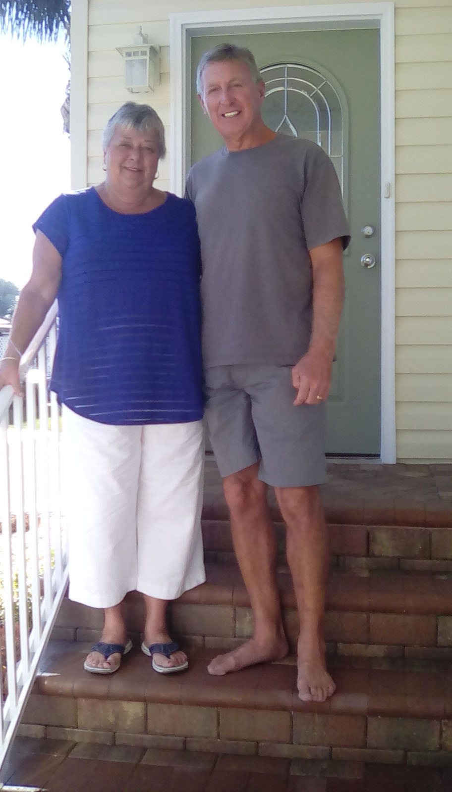
Since starting the Resident of the month articles, I’ve had the privilege of talking with some amazing individuals that make Southwinds such a great place in which to live. Luckily, for us, these volunteers are a very diverse group of people and contribute in so many different ways. Some of them have lived here for years. Others, like these in our March issue, have only been here a few years, however, what an impact they have made!! Let me introduce Carl & Joyce Johnson, the moving force behind the beautiful landscaping at the front of our park. They work tirelessly to make sure it is maintained. Thank you so much, you are appreciated..
Carl & Joyce provided this background.
Our initial visit to Southwinds was because of Joyce’s parents, Bob & Betty DeAnthony. They lived here part time for approximately 10 years and were always talking about how great the park was and the many friends they had made. We vacationed with them here when our kids were small and really enjoyed it. Our “kids”--- Eric (32) lives in Buffalo, NY with wife Leah and Stephen (42) lives in Coldwater, Ohio.
Both of us worked for Crown Equipment Corporation. I worked for Crown almost 33 years and retired as Commodity Manager in Purchasing. Joyce retired as Logistics Coordinator after 18 years. We knew that after retirement we wanted to spend the winter months in Sarasota. Because of this great community and the proximity to beaches, restaurants, theaters, shopping, etc., we decided Southwinds was the logical choice.
We rented in January, 2010, for three months and before returning to Ohio, we purchased Unit#253. In 2014 we sold our home in Ohio and became permanent Florida residents. After trying out Florida living and Southwinds year round, we decided to remove our existing mobile and replace it with a manufactured home and are very happy that we did.

We spend part of our time in the park helping the garden club and volunteering for other activities.

On Jan. 4th, we celebrated our 50th wedding anniversary.

BOBBY PALERMO 

Back by popular demand...Bobby Palermo... Florida’s Neil Diamond.
Bobby was a huge hit when he appeared here two years ago,. Come and enjoy a professional, highly entertaining show of music and laughter. He’s just plain fun.

Time: Wednesday, March 1st, 7:30 p.m.
Tickets: $10.00
Ticket sellers: June Moyaert - #160 902-626-7307
Carol Proteau - #135 207-754-8890
Nora Chisamore – #122 315-771-0095
Bonnie Norton – #224 941-921-4092

HOBBY CLUB 
A trip throughout the park at night offers welcoming lights from some of the Hobby Club’s just completed flower pot lighthouses. The most recent project was half circle Christmas Tree napkins that, when folded, just looks like a Christmas Tree.
Activities for March include: March 1st - watercolor class, March 8th & 15th - Swedish weaving, March 22nd - watercolor class, and March 29th - our Luncheon (place to be determined)
Many different items were made with enthusiasm and some frustration. There certainly were many laughs, fun, and companionship. A great time to be with and make new friends. Why not join us on Wednesdays at 1PM in the Annex?!!!

OHIO BREAKFAST
Tuesday, March 7 at 9:30 AM
TooJay's Deli, 3501 S. Tamiami Tr.
Questions? Contact Herb or Mimi Manton Unit #146 (921-6844)
PA/WV/MD LUNCHEON Wed., March 15, 2017 11:30 am Marina Jack’s Info: Bill & Cookie Miller 941-921-9277
IA/IL/MN/WI LUNCHEON Harry’s Grill, 6606 S. Tamiami Trail Wed. March 15, 11:30 am Info: Karen Gyenge #107 309-792-3420
Northeast Luncheon Thursday, March 23, 2017 11:30 am Miller's Ale House Bee Ridge & Cattleman Rd Everyone is Welcome SUS on BB Info: Gerry Kochan 924-0892

JUST A REMINDER If someone you knew and loved passed away, you can honor them by making a donation to the Southwinds Memorial Fund in their name. Many projects have been done with these monies, half of the cost of the handicap doors at the hall, our organ, part of the front sign, the tribute to our original owners garden at the pool, and the latest, of course, the Board approval of some of the funds to help with the landscaping at the Rec Hall.

Spaghetti Dinner  Wed. March 15, 2017 ---- 4:30 – 6:30pm - $8.00
Come Support Your “Can You Dig It Landscapers”
One sitting – we will set up tables for big or small groups. BYOB –sit, relax and enjoy a drink. Your food will be served “piping hot” when you are ready! (Water, Tea and Coffee provided) (Contact Connie for group table reservations 924-4878 or email bcmccabe2@gmail.com )
Ticket sellers – Lynn Auten 218-770-4301 Unit 241 Joe and Paula Buesing 201-655-3542 Unit 84 Kathy and Dennis Feeney 773-418-2355 Unit 105
Loraine and Peter Milburn 506-647-8037 Unit 216
Georgette and Mike Faulkingham 207-461-6034 Unit 163

ANNUAL ST. PATRICK’S PARADE 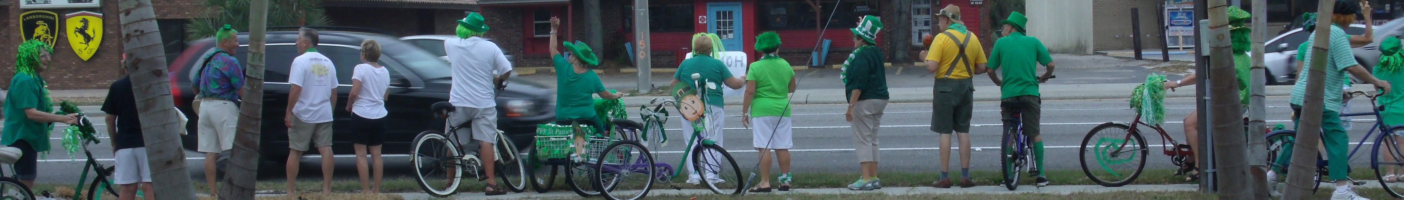
Friday, MARCH 17, 2017
MEET AT THE REC. HALL AT 9:15 AM
PARADE STARTS AT 9:30 AM
(Parade route posted on the bulletin board)
FOLLOWED BY REFRESHMENTS AND AWARDS AT THE Rec. hall
Then off to Hooters at 11:00 AM

A very Happy Birthday to John Kidd who will be 93 on March 4th.


John and Mary Butler, celebrating 62 years together on March 5th.
Harold & Ann Davies, celebrating 70 years together on March 14th
Congratulations & Best wishes from your Southwinds family


I want to thank everyone for me for the lovely card and good thoughts. I have a big fight ahead ahead but I'm planning on winning it and am grateful for my friends here in Southwinds.
Sally Nadelman

We cannot begin to express how much we appreciate the care and kindness we have received from our SOUTH WINDS. family. beautiful flowers, cards with encouraging notes, visits. We will never forget all of this--love to all. Bernice White
MARCH 2017

SUN | MON | TUES | WED  1Bobby  Palermo  7:30pm | THURS  2 | FRI  3 | SAT  4  Annual  Meeting  8:15am
5 | 6 | 7  Ohio  Bkfst  9:30am  Shuffle  Home  1pm | 8  POT  LUCK  5:30PM | 9 | 10 | 11 St.  Patrick’s  Dance  7:30pm
12 | 13Book  Club  1:30pm | 14  BOARD  MEETING | 15IA/IL/MN/WI  LNCHN 11:30AM  PA/WV/MD  LNCHN 11:30AM  Spaghetti  Dinner 4:30pm | 16 | 17  St. Pat’s  Parade  9:30am | 18  Rec  Club Coffee  9am  Park  Picnic  12pm
19 | 20 | 21  Shuffle  Home  1pm  Cloud 9  6:30pm | 22  POT  LUCK  5:30PM | 23  NE Lnchn 11:30am | 24 | 25  Bye  Bye  Birdie  Dance
26 | 27 | 28
HYMN SING- SUNDAY-6:45PM POOL EXERCISE-TUES/THURS-11AM
BINGO-MON & FRI-7PM HORSESHOES-TUES-10:00AM
CARDS-TUES & THURS 7PM BIBLE STUDY-FRI-9:30-10:30AM
BRIDGE-MON-7PM HOBBY CLUB- WED-1PM
SHUFFLE-MON/SAT-1PM BILLIARDS/POOL-MON-7PM
STRETCH CLASS -THURS- 9AM BOWLING-WED.- 9AM
WATER ZUMBA-MON.11-12AM BRIDGE – 7PM
PICKLE BALL -MON & THURS 9-11AM LINE DANCING 10-11AM
HOT TOPICS 10AM CORN HOLE 10-11AM
YOGA 10:30-11:30AM

